ANTENNA Q211D9XL
PERFORMANCES: (No loss condition)
TYPE | ELE | L (mm) | G (dBi) | F/B (dB) | F/Sh (dBi) | F/Sv (dBi) | Hor (◦) | Ver (◦) | Temp (◦K) | G/T (dB) | ΔF * (kHz)
Q211D9XL | 11 | 6358 | 15,60 | 21,97 | 21,02 | 18,30 | 32,2 | 34,1 | 227,6 | -7,97 | 3100
* ΔF given for SWR=1,5

PERFORMANCES: (Losses included)
Element material | G (dBi) | Temp (◦K) | G/T (dB)
Aluminum rods | 15,50 | 229,3 | -8,10

COMPARISON
Antenna | Boomlength (mm) | Material | Gain (dBi) | TA (◦K) | G/T (dB) | Bandwidth (MHz)
Q211D9XL | 6358 | No loss | 15,60 | 227,6 | -7,97 | 142,960-146,060
Q211D9XL | 6358 | Aluminum | 15,50 | 229,3 | -8,10 | 142,960-146,060
EF0211-5 | 6325 | No loss | 15,24 | 226,7 | -8,31 | 142,500-144,750
EF0211-5 | 6325 | Aluminum | 15,14 | 228,5 | -8,45 | 142,500-144,750

DIMENSIONS:
 | Ref | De | D1 | D2 | D3 | D4 | D5 | D6 | D7 | D8 | D9
Pos | 0 | 244 | 441 | 855 | 1465 | 2183 | 2992 | 3791 | 4682 | 5543 | 6358
Length | 786 | 740 | 714 | 698 | 676 | 654 | 638 | 628 | 614 | 606 | 600

REMARKS: | - All elements made of Al rods Ǿ5 mm  - The height of all rectangles is 320 mm  - All dimensions given in milimetres

DIAGRAMS (no loss included)
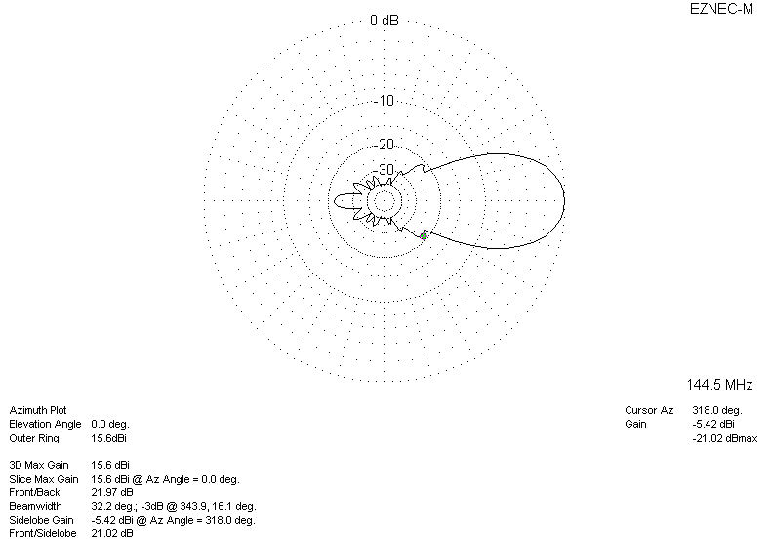
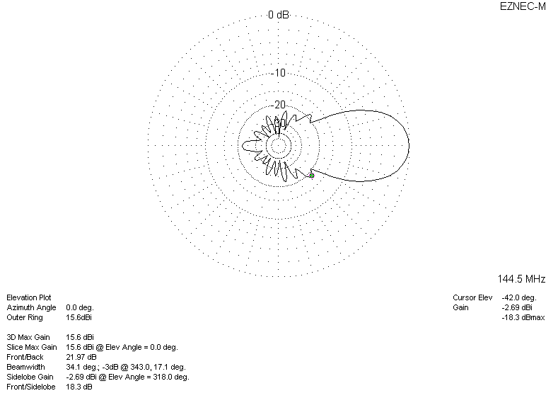

LOSSES INCLUDED
