ANTENNA Q211D8XL
PERFORMANCES: (No loss condition)
TYPE | ELE | L (mm) | G (dBi) | F/B (dB) | F/Sh (dBi) | F/Sv (dBi) | Hor (◦) | Ver (◦) | Temp (◦K) | G/T (dB) | ΔF * (kHz)
Q211D8XL | 11 | 6000 | 15,23 | 26,80 | 22,40 | 19,18 | 34,0 | 36,3 | 224,0 | -8,27 | 3710
* ΔF given for SWR=1,5

PERFORMANCES: (Losses included)
Element material | G (dBi) | Temp (◦K) | G/T (dB)
Aluminum rods | 15,14 | 225,5 | -8,39

COMPARISON
Antenna | Boomlength (mm) | Material | Gain (dBi) | TA (◦K) | G/T (dB) | Bandwidth  (MHz)
Q211D8XL | 6000 | No loss | 15,23 | 224,0 | -8,27 | 141,190-145,700
Q211D8XL | 6000 | Aluminum | 15,14 | 225,5 | -8,39 | 141,190-145,700
EF0211B-5 | 5980 | No loss | 15,13 | 229,1 | -8,47 | 140,600-145,210
EF0211B-5 | 5980 | Aluminum | 15,03 | 230,8 | -8,60 | 140,600-145,210
EF0211-5 | 6325 | No loss | 15,24 | 226,7 | -8,31 | 142,500-144,750
EF0211-5 | 6325 | Aluminum | 15,14 | 228,5 | -8,45 | 142,500-144,750

DIMENSIONS:
 | Ref | De | D1 | D2 | D3 | D4 | D5 | D6 | D7 | D8 | D9 | - All elements made of Al rods Ǿ5 mm  - The height of all rectangles is 320mm  - All dimensions given in milimetres
Pos | 0 | 295 | 532 | 973 | 1395 | 1958 | 2744 | 3608 | 4435 | 5335 | 6000
Length | 786 | 748 | 718 | 676 | 668 | 654 | 638 | 620 | 610 | 600 | 590

DIAGRAMS (no loss included)
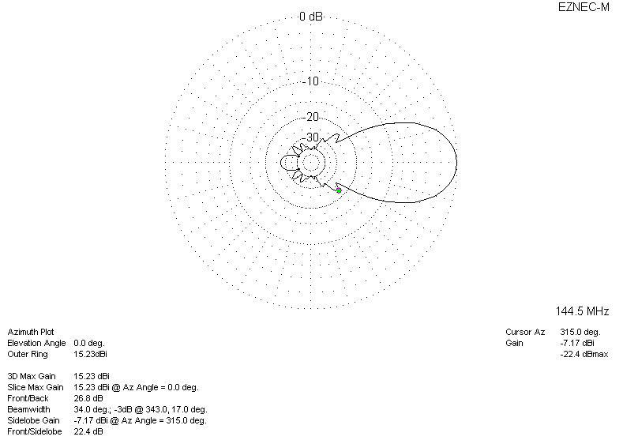
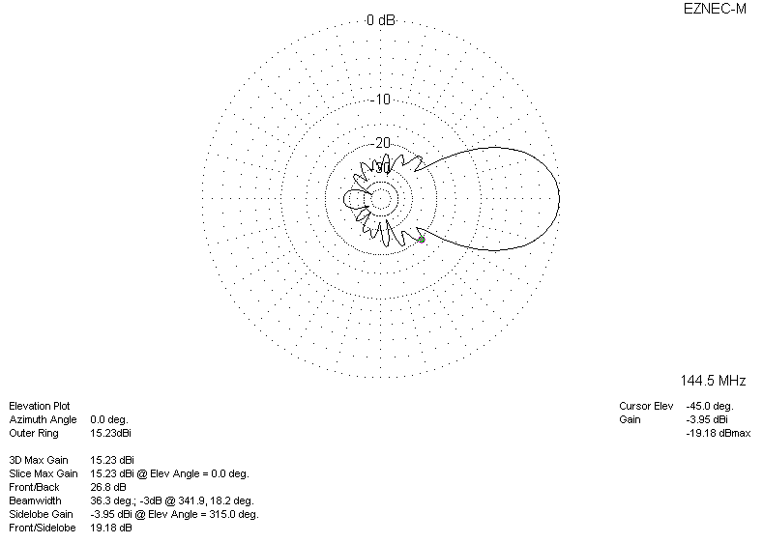

LOSSES INCLUDED
