ANTENNA Q211D1XL
PERFORMANCES: (No loss condition)
TYPE | ELE | L (mm) | G (dBi) | F/B (dB) | F/Sh (dBi) | F/Sv (dBi) | Hor (◦) | Ver (◦) | Temp (◦K) | G/T (dB) | ΔF * (kHz)
Q211D1XL | 11 | 5990 | 15,41 | 36,46 | 21,17 | 17,86 | 33,6 | 35,9 | 223,2 | -8,08 | 1660
* ΔF given for SWR=1,5

PERFORMANCES: (Losses included)
Element material | G (dBi) | Temp (◦K) | G/T (dB)
Aluminum rods | 15,30 | 225,1 | -8,22

COMPARISON
Antenna | Boomlength (mm) | Material | Gain (dBi) | TA (◦K) | G/T (dB) | Bandwidth (MHz)
Q211D1XL | 5990 | No loss | 15,41 | 223,2 | -8,08 | 143,630-145,290
Q211D1XL | 5990 | Aluminum | 15,30 | 225,1 | -8,22 | 143,630-145,290
EF0211B-5 | 5980 | No loss | 15,13 | 229,1 | -8,47 | 140,600-145,210
EF0211B-5 | 5980 | Aluminum | 15,03 | 230,8 | -8,60 | 140,600-145,210

DIMENSIONS:
 | Ref | De | D1 | D2 | D3 | D4 | D5 | D6 | D7 | D8 | D9
Pos | 0 | 331 | 499 | 809 | 1095 | 1721 | 2559 | 3438 | 4289 | 5208 | 5990
Length | 790 | 734 | 722 | 682 | 672 | 662 | 642 | 630 | 618 | 604 | 592

REMARKS: | - All elements made of Al rods Ǿ5 mm  - The height of all rectangles is 320 mm  - All dimensions given in milimetres

DIAGRAMS (no loss included)
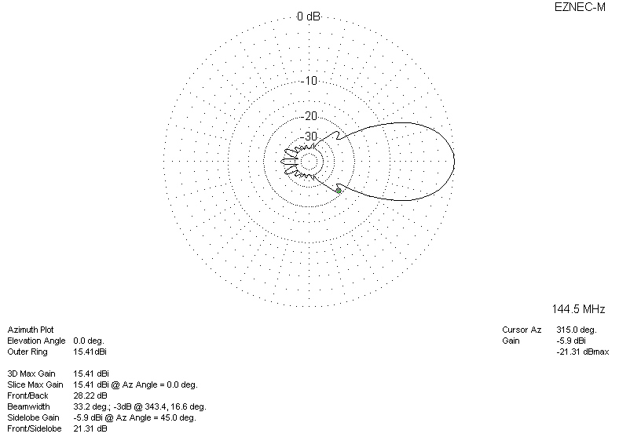
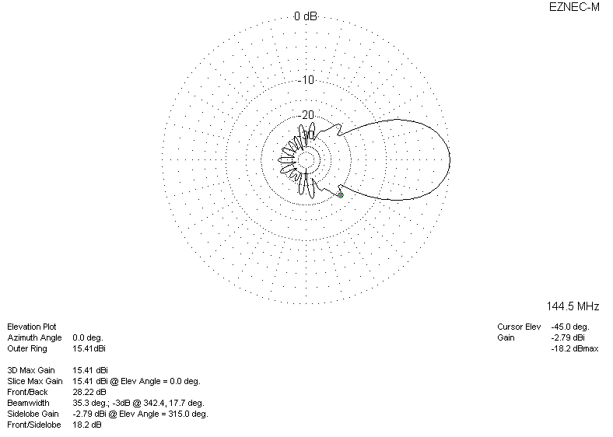

LOSSES INCLUDED
