ANTENNA Q210H3XL
PERFORMANCES: (No loss condition)
TYPE | ELE | L (mm) | G (dBi) | F/B (dB) | F/Sh (dBi) | F/Sv (dBi) | Hor (◦) | Ver (◦) | Temp (◦K) | G/T (dB) | ΔF * (kHz)
Q210H3XL | 10 | 6445 | 15,50 | 22,93 | 20,75 | 18,50 | 33,6 | 34,8 | 225,6 | -8,03 | 2540
* ΔF given for SWR=1,5

PERFORMANCES: (Losses included)
Element material | G (dBi) | Temp (◦K) | G/T (dB)
Aluminum rods | 15,39 | 227,6 | -8,18

DIMENSIONS:
 | Ref | De | D1 | D2 | D3 | D4 | D5 | D6 | D7 | D8 | - All elements made of Al rods Ǿ5 mm  - The height of all rectangles is 500 mm - All dimensions given in milimetres
Pos | 0 | 383 | 658 | 1235 | 2025 | 2875 | 3761 | 4698 | 5605 | 6445
Length | 624 | 578 | 562 | 542 | 520 | 508 | 490 | 478 | 470 | 460

COMPARISON
Antenna | Boomlength (mm) | Material | Gain (dBi) | TA (◦K) | G/T (dB) | Beamwidth  (MHz)
Q210H3XL | 6445 | No loss | 15,50 | 225,6 | -8,10 | 143,100-145,640
Q210H3XL | 6445 | Aluminum | 15,39 | 227,6 | -8,23 | 143,100-145,640
EF0211-5 | 6325 | No loss | 15,24 | 226,7 | -8,31 | 142,500-144,750
EF0211-5 | 6325 | Aluminum | 15,14 | 228,5 | -8,45 | 142,500-144,750

DIAGRAMS (no loss included)

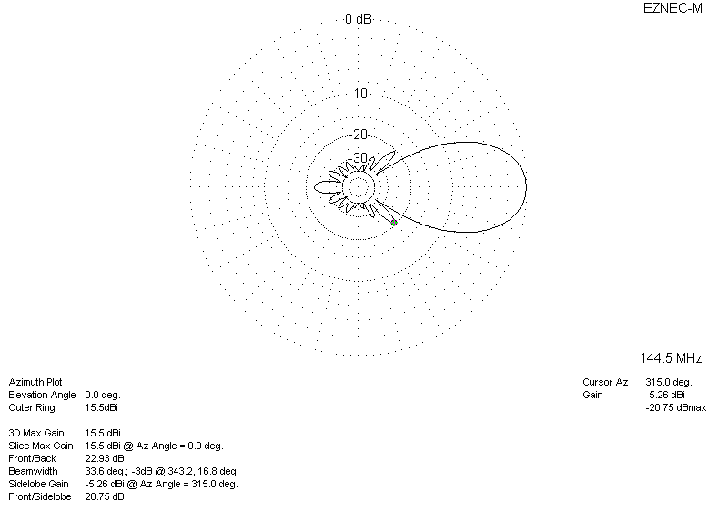

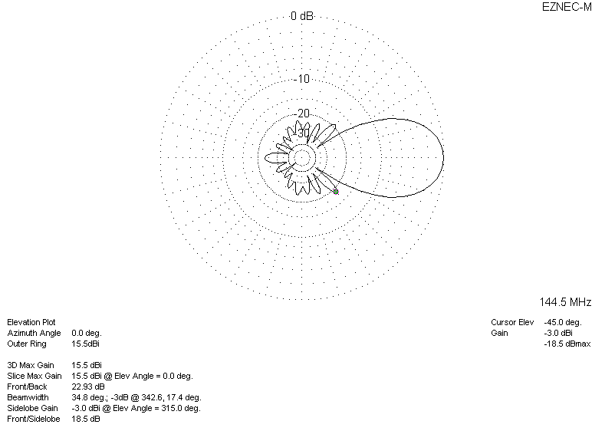
DIAGRAMS (losses included)
