ANTENNA Q210H1XL
PERFORMANCES: (No loss condition)
TYPE | ELE | L (mm) | G (dBi) | F/B (dB) | F/Sh (dBi) | F/Sv (dBi) | Hor (◦) | Ver (◦) | Temp (◦K) | G/T (dB) | ΔF * (kHz)
Q210H1XL | 10 | 6493 | 15,59 | 26,24 | 19,924 | 16,97 | 32,8 | 33,9 | 233,9 | -8,10 | 2940
* ΔF given for SWR=1,5

PERFORMANCES: (Losses included)
Element material | G (dBi) | Temp (◦K) | G/T (dB)
Aluminum rods | 15,49 | 235,5 | -8,23

DIMENSIONS:
 | Ref | De | D1 | D2 | D3 | D4 | D5 | D6 | D7 | D8 | - All elements made of Al rods Ǿ5 mm  - The height of all rectangles is 500 mm - All dimensions given in milimetres
Pos | 0 | 419 | 791 | 1348 | 2186 | 3046 | 3882 | 4786 | 5647 | 6493
Length | 620 | 578 | 564 | 540 | 516 | 506 | 498 | 490 | 482 | 468

COMPARISON
Antenna | Boomlength (mm) | Material | Gain (dBi) | TA (◦K) | G/T (dB) | Beamwidth  (MHz)
Q210XLG | 6493 | No loss | 15,59 | 233,9 | -8,10 | 142,890-145,830
Q210XLG | 6493 | Aluminum | 15,49 | 235,5 | -8,23 | 142,890-145,830
EF0211-5 | 6325 | No loss | 15,24 | 226,7 | -8,31 | 142,500-144,750
EF0211-5 | 6325 | Aluminum | 15,14 | 228,5 | -8,45 | 142,500-144,750

DIAGRAMS (no loss included)

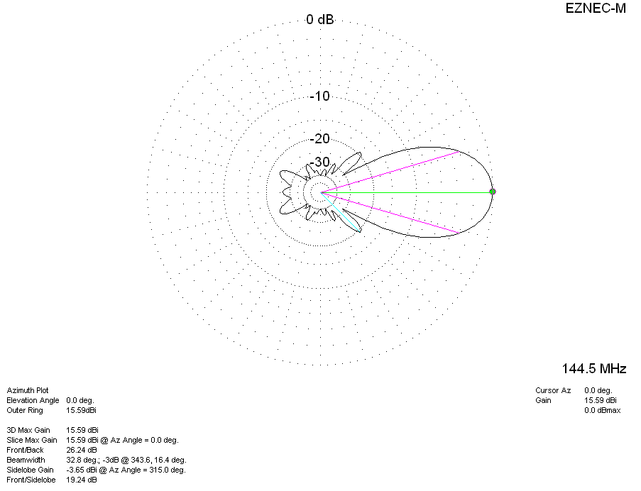

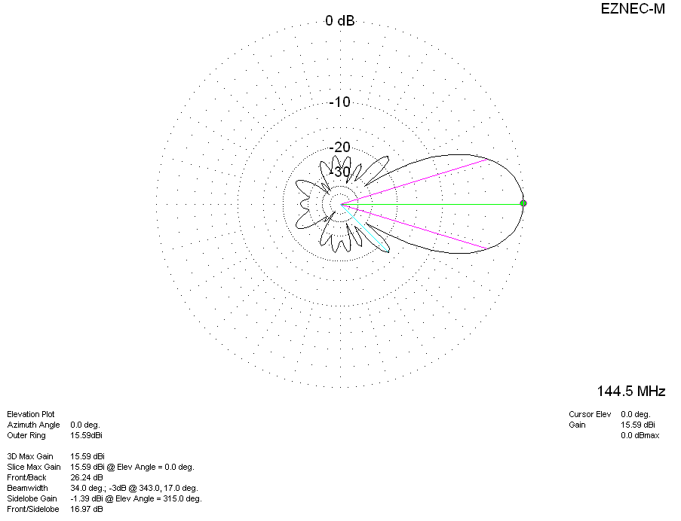
DIAGRAMS (losses included)
