ANTENNA Q210F4XL
PERFORMANCES: (No loss condition)
TYPE | ELE | L (mm) | G (dBi) | F/B (dB) | F/Sh (dBi) | F/Sv (dBi) | Hor (◦) | Ver (◦) | Temp (◦K) | G/T (dB) | ΔF * (kHz)
Q210F4XL | 10 | 5985 | 15,24 | 23,87 | 20,20 | 17,49 | 34,2 | 35,9 | 230,8 | -8,39 | 2760
* ΔF given for SWR=1,5

PERFORMANCES: (Losses included)
Element material | G (dBi) | Temp (◦K) | G/T (dB)
Aluminum rods | 15,15 | 232,3 | -8,51

DIMENSIONS:
 | Ref | De | D1 | D2 | D3 | D4 | D5 | D6 | D7 | D8 | - All elements made of Al rods Ǿ5 mm  - The height of all rectangles is 440 mm  - All dimensions given in milimeters
Pos | 0 | 402 | 807 | 1425 | 2195 | 3012 | 3805 | 4615 | 5381 | 5985
Length | 684 | 635 | 610 | 590 | 560 | 546 | 536 | 526 | 518 | 508

COMPARISON
Antenna | Boomlength (mm) | Material | Gain (dBi) | TA (◦K) | G/T (dB) | Bandwidth  (MHz)
Q210F4XL | 5985 | No loss | 15,24 | 230,8 | -8,39 | 142,600-145,360
Q210F4XL | 5985 | Aluminum | 15,15 | 232,3 | -8,51 | 142,600-145,360
EF0211B-5 | 5980 | No loss | 15,13 | 229.1 | -8,47 | 140,600-145,210
EF0211B-5 | 5980 | Aluminum | 15,03 | 230,8 | -8,60 | 140,600-145,210

DIAGRAMS (no loss included)
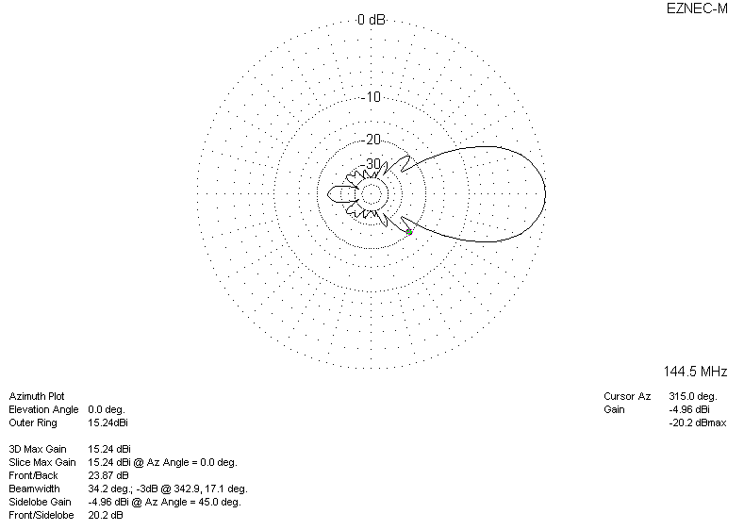
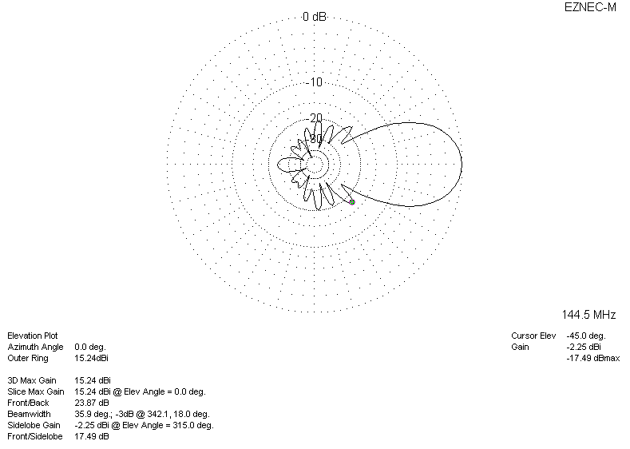
DIAGRAMS (losses included)
