ANTENNA Q210E1XL
PERFORMANCES: (No loss condition)
TYPE | ELE | L (mm) | G (dBi) | F/B (dB) | F/Sh (dBi) | F/Sv (dBi) | Hor (◦) | Ver (◦) | Temp (◦K) | G/T (dB) | ΔF * (kHz)
Q210E1XL | 10 | 6215 | 15,69 | 26,19 | 20,29 | 17,51 | 32,0 | 33,5 | 230,6 | -7,94 | 1930
* ΔF given for SWR=1,5

PERFORMANCES: (Losses included)
Element material | G (dBi) | Temp (◦K) | G/T (dB)
Aluminum rods | 15,56 | 232,6 | -8,23

DIMENSIONS:
 | Ref | De | D1 | D2 | D3 | D4 | D5 | D6 | D7 | D8 | - All elements made of Al rods Ǿ5 mm  - The height of all rectangles is 400 mm - All dimensions given in milimetres
Pos | 0 | 330 | 550 | 1109 | 1879 | 2691 | 3562 | 4488 | 5305 | 6215
Length | 712 | 670 | 652 | 624 | 606 | 588 | 576 | 562 | 556 | 550

COMPARISON
Antenna | Boomlength (mm) | Material | Gain (dBi) | TA (◦K) | G/T (dB) | Beamwidth  (MHz)
Q210E1XL | 6215 | No loss | 15,69 | 230,6 | -7,94 | 143,390-145,320
Q210E1XL | 6215 | Aluminum | 15,56 | 232,6 | -8,23 | 143,390-145,320
EF0211-5 | 6325 | No loss | 15,24 | 226,7 | -8,31 | 142,500-144,750
EF0211-5 | 6325 | Aluminum | 15,14 | 228,5 | -8,45 | 142,500-144,750

DIAGRAMS (no loss included)

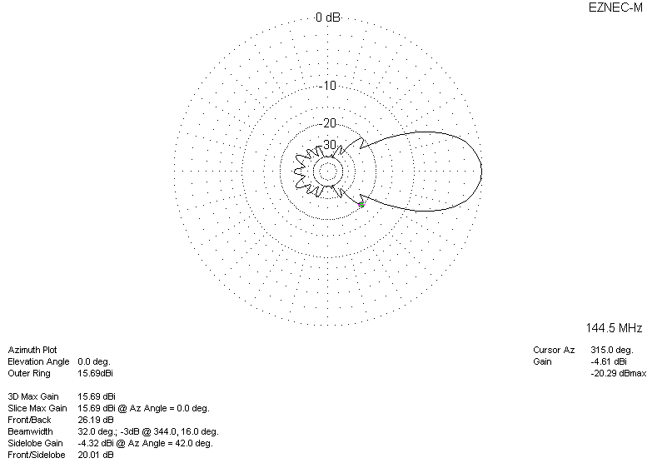

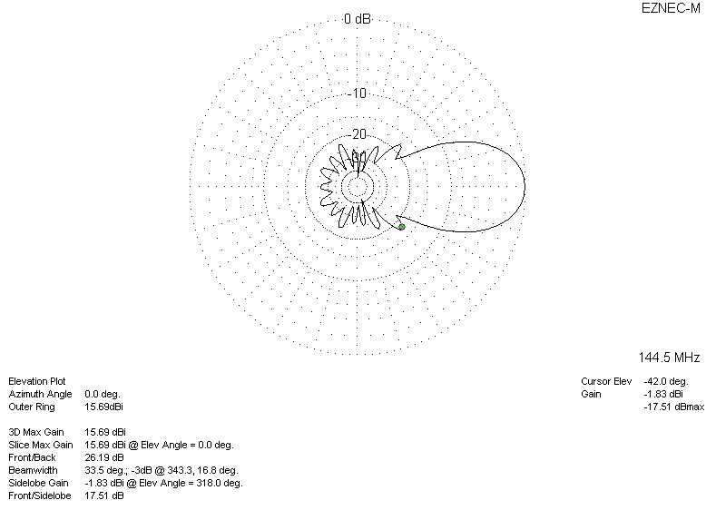
DIAGRAMS (losses included)
