ANTENNA Q210D9XL
PERFORMANCES: (No loss condition)
TYPE | ELE | L (mm) | G (dBi) | F/B (dB) | F/Sh (dBi) | F/Sv (dBi) | Hor (◦) | Ver (◦) | Temp (◦K) | G/T (dB) | ΔF * (kHz)
Q210D9XL | 10 | 5450 | 15,05 | 21,75 | 21,43 | 18,17 | 34,4 | 36,7 | 229,6 | -8,56 | 3400
* ΔF given for SWR=1,5

PERFORMANCES: (Losses included)
Element material | G (dBi) | Temp (◦K) | G/T (dB)
Aluminum rods | 14,95 | 231,2 | -8,69

DIMENSIONS:
 | Ref | De | D1 | D2 | D3 | D4 | D5 | D6 | D7 | D8 | - All elements made of Al rods Ǿ5 mm  - The height of all rectangles is 320 mm - All dimensions given in milimetres
Pos | 0 | 255 | 458 | 855 | 1465 | 2183 | 2992 | 3801 | 4672 | 5450
Length | 788 | 741 | 712 | 698 | 674 | 652 | 636 | 626 | 610 | 602

COMPARISON
Antenna | Boomlength (mm) | Material | Gain (dBi) | TA (◦K) | G/T (dB) | Beamwidth  (MHz)
Q210D9XL | 5450 | No loss | 15,05 | 229,6 | -8,56 | 142,560-145,960
Q210D9XL | 5450 | Aluminum | 14,95 | 231,2 | -8,69 | 142,560-145,960
EF0210-5 | 5290 | No loss | 14,77 | 233,8 | -8,92 | 140,190-145,450
EF0210-5 | 5290 | Aluminum | 14,67 | 235,4 | -9,05 | 140,190-145,450

DIAGRAMS (no loss included)

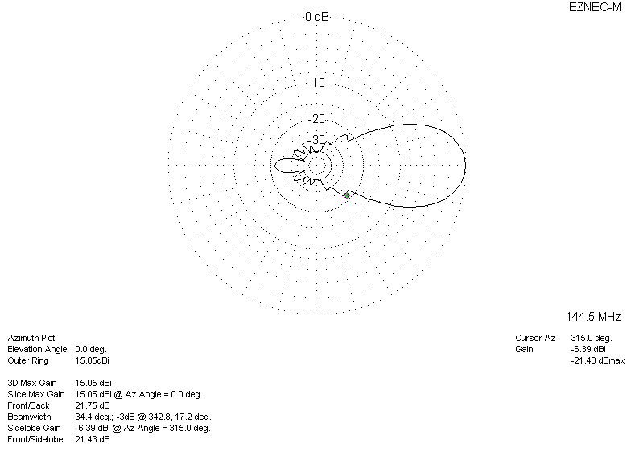

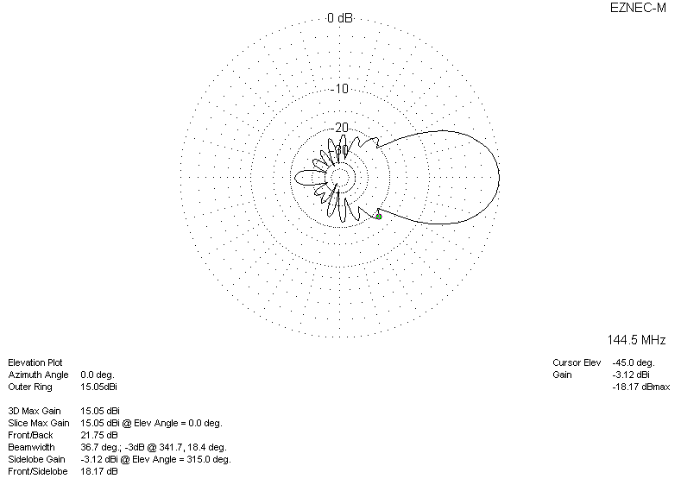
DIAGRAMS (losses included)
