ANTENNA Q210D7XL
PERFORMANCES: (No loss condition)
TYPE | ELE | L (mm) | G (dBi) | F/B (dB) | F/Sh (dBi) | F/Sv (dBi) | Hor (◦) | Ver (◦) | Temp (◦K) | G/T (dB) | ΔF * (kHz)
Q210D7XL | 10 | 5319 | 14,91 | 20,85 | 22,40 | 19,18 | 35,2 | 37,5 | 229,3 | -8,69 | 2850
* ΔF given for SWR=1,5

PERFORMANCES: (Losses included)
Element material | G (dBi) | Temp (◦K) | G/T (dB)
Aluminum rods | 14,82 | 230,7 | -8,81

DIMENSIONS:
 | Ref | De | D1 | D2 | D3 | D4 | D5 | D6 | D7 | D8 | - All elements made of Al rods Ǿ5 mm  - The height of all rectangles is 320 mm - All dimensions given in milimetres
Pos | 0 | 298 | 533 | 973 | 1395 | 1958 | 2744 | 3608 | 4425 | 5319
Length | 786 | 741 | 718 | 676 | 668 | 654 | 638 | 620 | 610 | 600

COMPARISON
Antenna | Boomlength (mm) | Material | Gain (dBi) | TA (◦K) | G/T (dB) | Beamwidth  (MHz)
Q210D7XL | 5319 | No loss | 14,91 | 229,3 | -8,69 | 143,180-146,030
Q210D7XL | 5319 | Aluminum | 14,82 | 230,7 | -8,81 | 143,180-146,030
EF0210-5 | 5290 | No loss | 14,77 | 233,8 | -8,92 | 140,190-145,450
EF0210-5 | 5290 | Aluminum | 14,67 | 235,4 | -9,05 | 140,190-145,450

DIAGRAMS (no loss included)

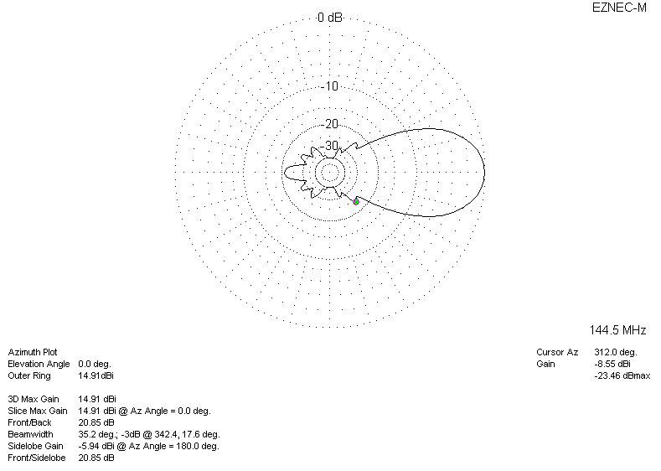

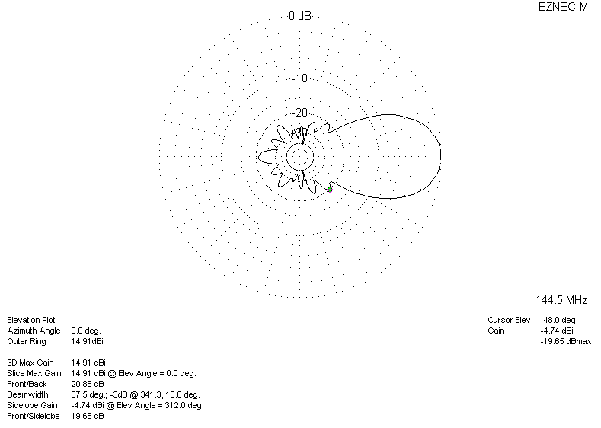
DIAGRAMS (losses included)
