ANTENNA Q210C1XL
PERFORMANCES: (No loss condition)
TYPE | ELE | L (mm) | G (dBi) | F/B (dB) | F/Sh (dBi) | F/Sv (dBi) | Hor (◦) | Ver (◦) | Temp (◦K) | G/T (dB) | ΔF * (kHz)
Q210C1XL | 10 | 6348 | 15,38 | 23,56 | 22,84 | 19,48 | 33,6 | 35,9 | 220,1 | -8,05 | 2870
* ΔF given for SWR=1,5

PERFORMANCES: (Losses included)
Element material | G (dBi) | Temp (◦K) | G/T (dB)
Aluminum rods | 15,29 | 221,7 | -8,17

DIMENSIONS:
 | Ref | De | D1 | D2 | D3 | D4 | D5 | D6 | D7 | D8 | - All elements made of Al rods Ǿ5 mm  - The height of all rectangles is 300 mm - All dimensions given in milimetres
Pos | 0 | 310 | 653 | 1267 | 1976 | 2788 | 3649 | 4539 | 5389 | 6348
Length | 806 | 752 | 728 | 696 | 672 | 652 | 638 | 618 | 594 | 578

COMPARISON
Antenna | Boomlength (mm) | Material | Gain (dBi) | TA (◦K) | G/T (dB) | Beamwidth  (MHz)
Q210C1XL | 6348 | No loss | 15,38 | 220,1 | -8,05 | 143,250-146,120
Q210C1XL | 6348 | Aluminum | 15,29 | 221,7 | -8,17 | 143,250-146,120
EF0211-5 | 6325 | No loss | 15,24 | 226,7 | -8,31 | 142,500-144,750
EF0211-5 | 6325 | Aluminum | 15,14 | 228,5 | -8,45 | 142,500-144,750

DIAGRAMS (no loss included)

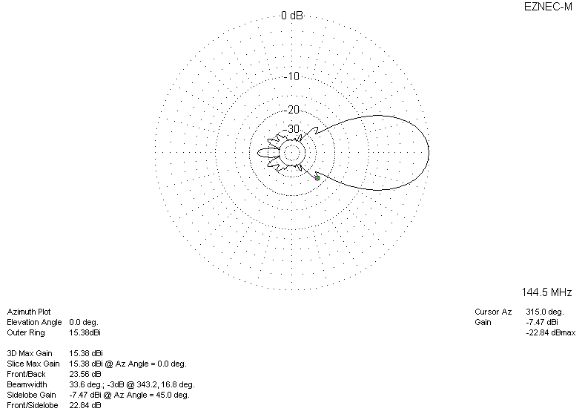

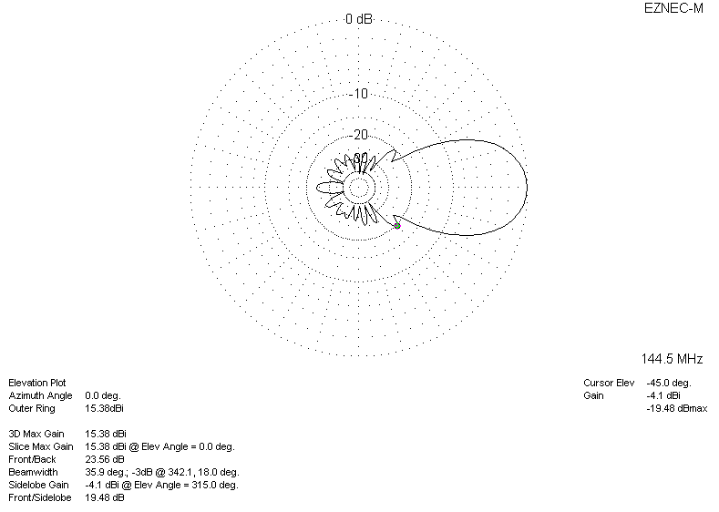
DIAGRAMS (losses included)
