PERFORMANCES: (No loss condition)
TYPE | ELE | L (mm) | G (dBi) | F/B (dB) | F/Sh (dBi) | F/Sv (dBi) | Hor (◦) | Ver (◦) | Temp (◦K) | G/T (dB) | ΔF * (kHz)
Q209H2XL | 8 | 4645 | 14,47 | 21,53 | 21,24 | 18,05 | 37,4 | 39,0 | 235,9 | -9,26 | 2990
* ΔF given for SWR=1,5

PERFORMANCES: (Losses included)
Element material | G (dBi) | Temp (◦K) | G/T (dB)
Aluminum rods | 14,38 | 237,2 | -9,37

DIMENSIONS:
 | Ref | De | D1 | D2 | D3 | D4 | D5 | D6 | D7
Pos | 0 | 395 | 551 | 925 | 1409 | 1972 | 2725 | 3576 | 4355
Length | 788 | 742 | 720 | 684 | 672 | 654 | 640 | 622 | 612

REMARKS: : - All elements made of Al rods Ǿ5 mm
- The height of all rectangles is 500 mm
- All dimensions given in milimetres

COMPARISON
Antenna | Boomlength (mm) | Material | Gain (dBi) | TA (◦K) | G/T (dB)
Q209H2XL | 4645 | No loss | 14,47 | 235,9 | -9,26
Q209H2XL | 4645 | Aluminum | 14,38 | 237,2 | -9,37
EF0209-5 | 4490 | No loss | 14,06 | 239,8 | -9,74
EF0209-5 | 4490 | Aluminum | 13,99 | 240,9 | -9,83

DIAGRAMS (no loss included)

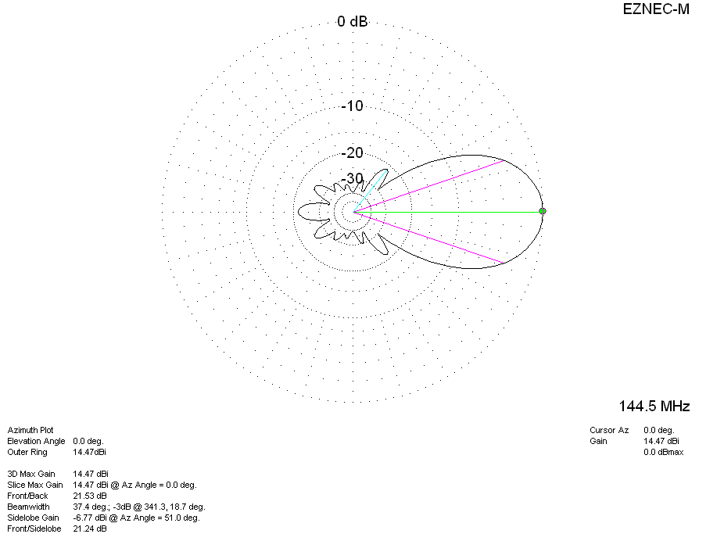
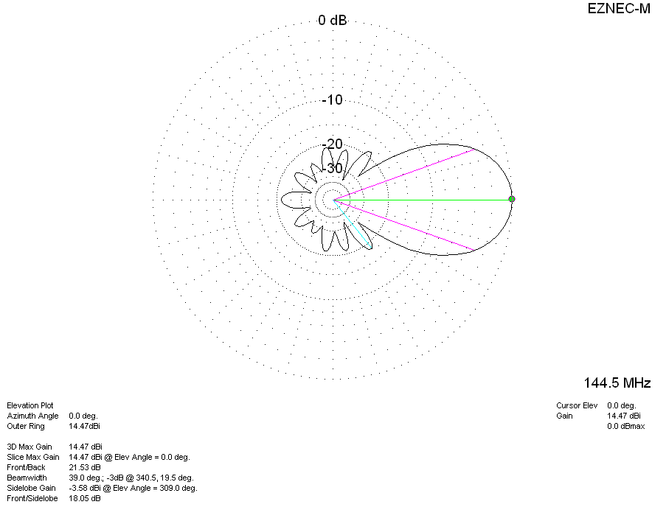
LOSS INCLUDED
