ANTENNA Q209H1XL
PERFORMANCES: (No loss condition)
TYPE | ELE | L (mm) | G (dBi) | F/B (dB) | F/Sh (dBi) | F/Sv (dBi) | Hor (◦) | Ver (◦) | Temp (◦K) | G/T (dB) | ΔF * (kHz)
Q209H1XL | 9 | 5545 | 14,97 | 20,92 | 21,82 | 19,12 | 35,6 | 37,0 | 229,7 | -8,64 | 2960
* ΔF given for SWR=1,5

PERFORMANCES: (Losses included)
Element material | G (dBi) | Temp (◦K) | G/T (dB)
Aluminum rods | 14,87 | 231,4 | -8,77

DIMENSIONS:
 | Ref | De | D1 | D2 | D3 | D4 | D5 | D6 | D7 | - All elements made of Al rods Ǿ5 mm  - The height of all rectangles is 500 mm  - All dimensions given in milimeters
Pos | 0 | 365 | 659 | 1235 | 2035 | 2875 | 3741 | 4698 | 5545
Length | 624 | 578 | 562 | 542 | 518 | 504 | 486 | 474 | 466

COMPARISON
Antenna | Boomlength (mm) | Material | Gain (dBi) | TA (◦K) | G/T (dB)
Q209H1XL | 5545 | No loss | 14,97 | 229,7 | -8,64 | 143,000-145,960
Q209H1XL | 5545 | Aluminum | 14,87 | 231,4 | -8,77 | 143,000-145,960
EF0210-5 | 5290 | No loss | 14,77 | 233,8 | -8,92 | 140,190-145,450
EF0210-5 | 5290 | Aluminum | 14,67 | 235,4 | -9,05 | 140,190-145,450

DIAGRAMS (no loss included)
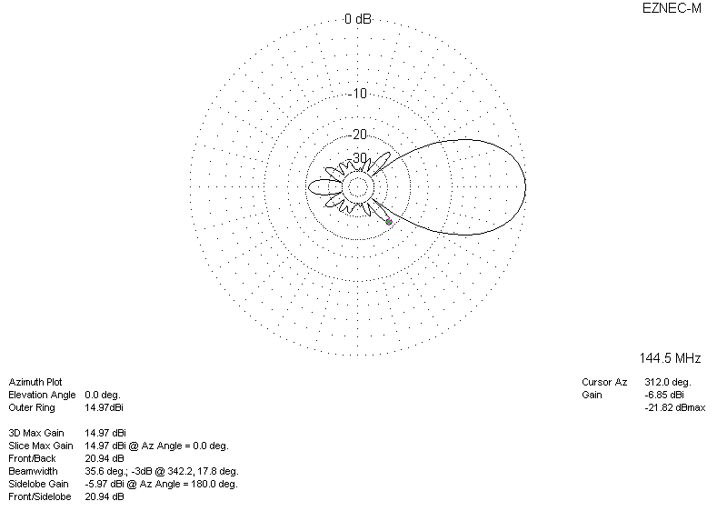
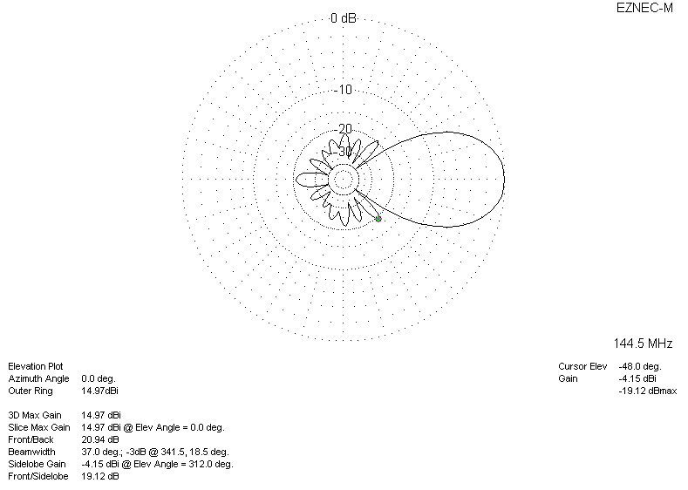
DIAGRAMS (losses included)
