ANTENNA Q209G2XL
PERFORMANCES: (No loss condition)
TYPE | ELE | L (mm) | G (dBi) | F/B (dB) | F/Sh (dBi) | F/Sv (dBi) | Hor (◦) | Ver (◦) | Temp (◦K) | G/T (dB) | ΔF * (kHz)
Q209G2XL | 9 | 5505 | 15,03 | 22,34 | 20,30 | 17,59 | 35,2 | 26,6 | 233,0 | -8,64 | 3050
* ΔF given for SWR=1,5

PERFORMANCES: (Losses included)
Element material | G (dBi) | Temp (◦K) | G/T (dB)
Aluminum rods | 14,93 | 234,1 | -8,77

DIMENSIONS:
 | Ref | De | D1 | D2 | D3 | D4 | D5 | D6 | D7
Pos | 0 | 416 | 792 | 1365 | 2176 | 3022 | 3839 | 4765 | 5505
Length | 620 | 578 | 563 | 539 | 517 | 506 | 495 | 486 | 474

REMARKS: : - All elements made of Al rods Ǿ5 mm
- The height of all rectangles is 500 mm
- All dimensions given in milimetres

COMPARISON
Antenna | Boomlength (mm) | Material | Gain (dBi) | TA (◦K) | G/T (dB) | Bandwidth  (MHz)
Q209G2XL | 5505 | No loss | 15,03 | 233,0 | -8,64 | 142,740-145,790
Q209G2XL | 5505 | Aluminum | 14,93 | 234,1 | -8,77 | 142,740-145,790
EF0210-5 | 5290 | No loss | 14,77 | 233,8 | -8,92 | 140,190-145,450
EF0210-5 | 5290 | Aluminum | 14,67 | 235,4 | -9,05 | 140,190-145,450

DIAGRAMS (no loss included)
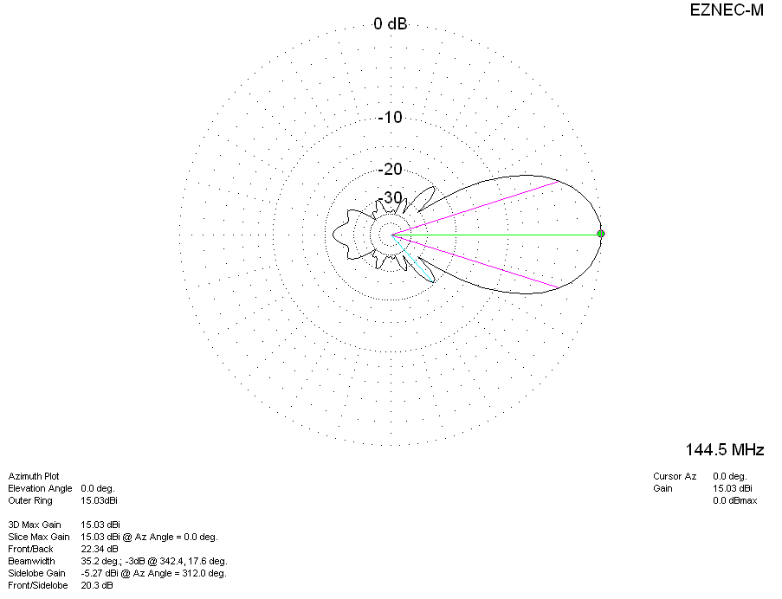
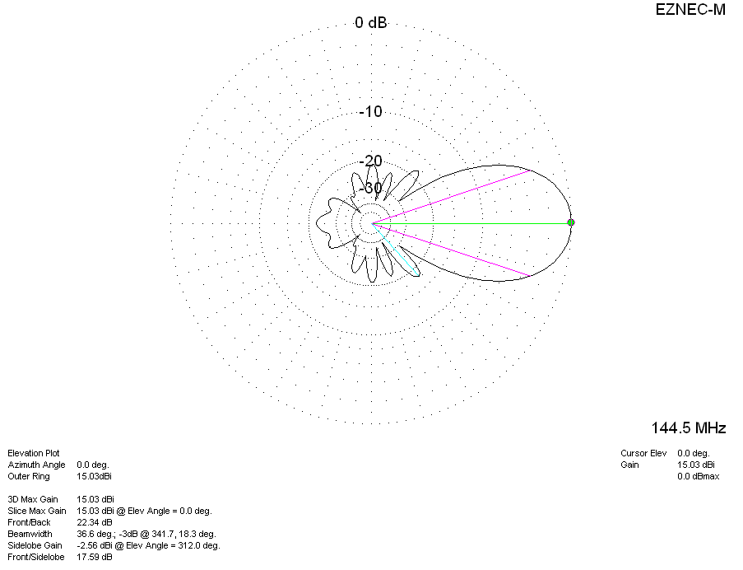
DIAGRAMS (Losses included)
