ANTENNA Q209F1XL
PERFORMANCES: (No loss condition)
TYPE | ELE | L (mm) | G (dBi) | F/B (dB) | F/Sh (dBi) | F/Sv (dBi) | Hor (◦) | Ver (◦) | Temp (◦K) | G/T (dB) | ΔF * (kHz)
Q209F1XL | 9 | 5572 | 15,11 | 21,26 | 20,95 | 17,95 | 34,6 | 36,3 | 234,1 | -8,58 | 2700
* ΔF given for SWR=1,5

PERFORMANCES: (Losses included)
Element material | G (dBi) | Temp (◦K) | G/T (dB)
Aluminum rods | 15,01 | 235,7 | -8,71

DIMENSIONS:
 | Ref | De | D1 | D2 | D3 | D4 | D5 | D6 | D7
Pos | 0 | 425 | 769 | 1336 | 2196 | 2982 | 3883 | 4729 | 5572
Length | 674 | 628 | 608 | 584 | 552 | 540 | 530 | 524 | 520

REMARKS: : - All elements made of Al rods Ǿ5 mm
- The height of all rectangles is 450 mm
- All dimensions given in milimetres

COMPARISON
Antenna | Boomlength (mm) | Material | Gain (dBi) | TA (◦K) | G/T (dB) | Bandwidth  (MHz)
Q209F1XL | 5572 | No loss | 15,11 | 234,1 | -8,58 | 142,800-145,500
Q209F1XL | 5572 | Aluminum | 15,01 | 235,7 | -8,71 | 142,800-145,500
EF0210-5 | 5290 | No loss | 14,77 | 233,8 | -8,92 | 140,190-145,450
EF0210-5 | 5290 | Aluminum | 14,67 | 235,4 | -9,05 | 140,190-145,450

DIAGRAMS (no loss included)
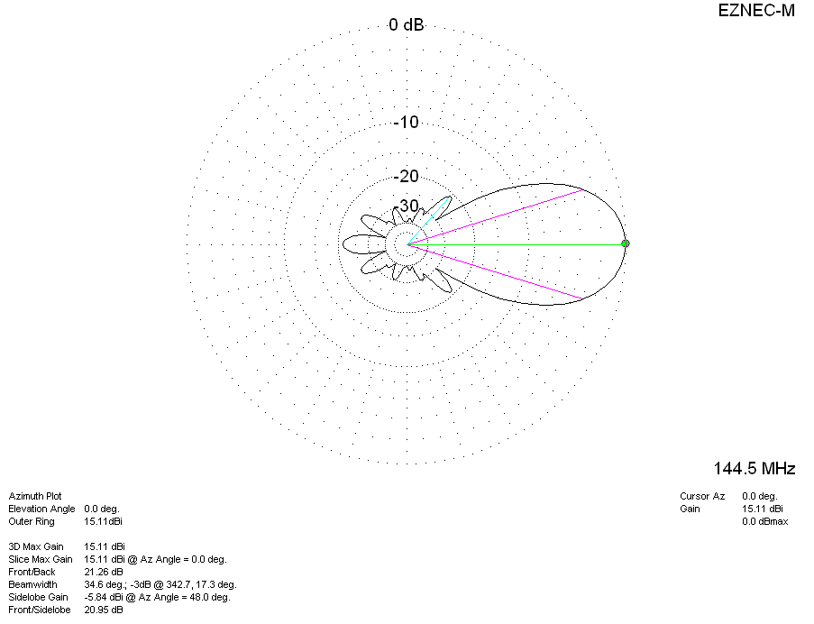
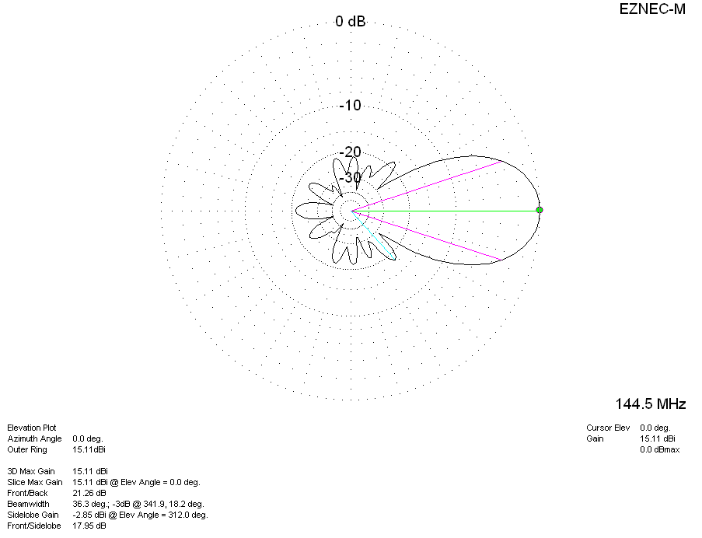
DIAGRAMS (losses incuded)
