ANTENNA Q209E3XL
PERFORMANCES: (No loss condition)
TYPE | ELE | L (mm) | G (dBi) | F/B (dB) | F/Sh (dBi) | F/Sv (dBi) | Hor (◦) | Ver (◦) | Temp (◦K) | G/T (dB) | ΔF * (kHz)
Q209E3XL | 9 | 4605 | 14,42 | 21,88 | 22,67 | 18,67 | 37,4 | 39,7 | 232,6 | -9,25 | 3820
* ΔF given for SWR=1,5

PERFORMANCES: (Losses included)
Element material | G (dBi) | Temp (◦K) | G/T (dB)
Aluminum rods | 14,34 | 233,9 | -9,35

DIMENSIONS:
 | Ref | De | D1 | D2 | D3 | D4 | D5 | D6 | D7 | - All elements made of Al rods Ǿ5 mm  - The height of all rectangles is 400 mm  - All dimensions given in milimeters
Pos | 0 | 325 | 572 | 968 | 1485 | 2195 | 2985 | 3855 | 4605
Length | 720 | 676 | 644 | 624 | 604 | 586 | 570 | 558 | 552

COMPARISON
Antenna | Boomlength (mm) | Material | Gain (dBi) | TA (◦K) | G/T (dB) | Bandwidth  (MHz)
Q209E3XL | 4605 | No loss | 14,42 | 232,6 | -9,25 | 141,780-145,600
Q209E3XL | 4605 | Aluminum | 14,34 | 233,9 | -9,35 | 141,780-145,600
EF0209-5 | 4490 | No loss | 14,06 | 239,8 | -9,74 | 140,100-145,480
EF0209-5 | 4490 | Aluminum | 13,99 | 240,9 | -9,83 | 140,100-145,480

DIAGRAMS (no loss included)
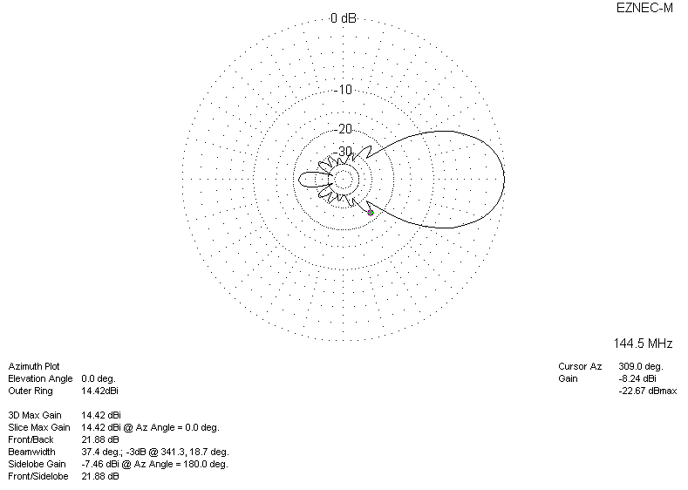
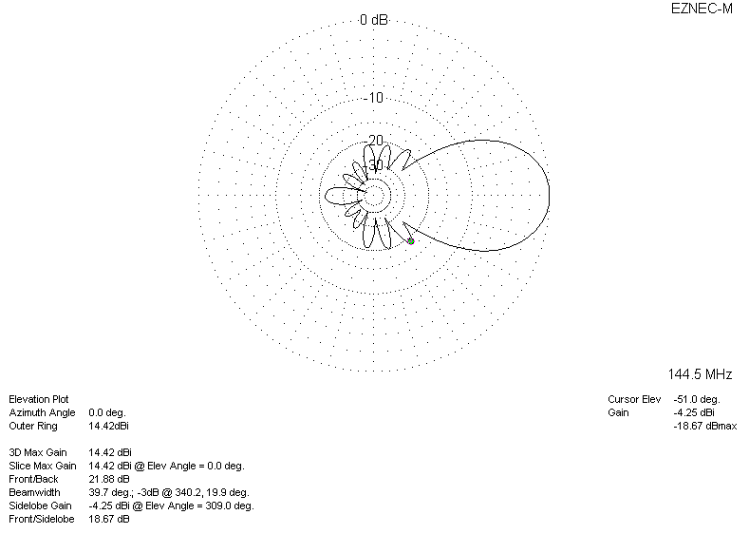
DIAGRAMS (losses included)
