ANTENNA Q209E1XL
PERFORMANCES: (No loss condition)
TYPE | ELE | L (mm) | G (dBi) | F/B (dB) | F/Sh (dBi) | F/Sv (dBi) | Hor (◦) | Ver (◦) | Temp (◦K) | G/T (dB) | ΔF * (kHz)
Q209E1XL | 9 | 5265 | 15,14 | 22,78 | 20,71 | 17,42 | 34,2 | 36,1 | 232,0 | -8,52 | 2020
* ΔF given for SWR=1,5

PERFORMANCES: (Losses included)
Element material | G (dBi) | Temp (◦K) | G/T (dB)
Aluminum rods | 15,02 | 233,8 | -8,67

DIMENSIONS:
 | Ref | De | D1 | D2 | D3 | D4 | D5 | D6 | D7 | - All elements made of Al rods Ǿ5 mm  - The height of all rectangles is 400 mm  - All dimensions given in milimeters
Pos | 0 | 328 | 550 | 1109 | 1879 | 2691 | 3562 | 4484 | 5265
Length | 708 | 670 | 652 | 624 | 602 | 584 | 572 | 562 | 556

COMPARISON
Antenna | Boomlength (mm) | Material | Gain (dBi) | TA (◦K) | G/T (dB) | Bandwidth  (MHz)
Q209D1XL | 5265 | No loss | 15,14 | 232,0 | -8,52 | 141,780-145,600
Q209D1XL | 5265 | Aluminum | 15,02 | 233,8 | -8,67 | 141,780-145,600
EF0210-5 | 5290 | No loss | 14,77 | 233,8 | -8,92 | 140,190-145,450
EF0210-5 | 5290 | Aluminum | 14,67 | 235,4 | -9,05 | 140,190-145,450

DIAGRAMS (no loss included)
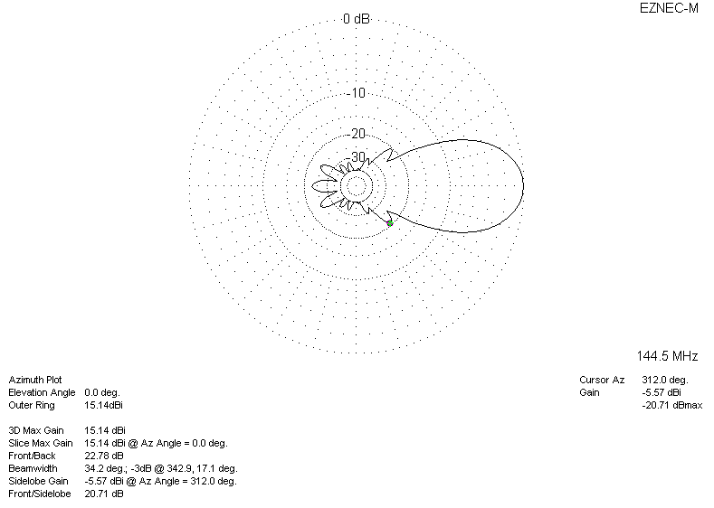
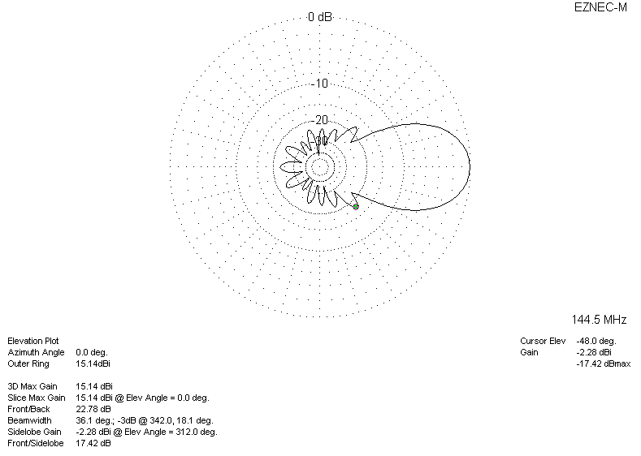
DIAGRAMS (losses included)
