ANTENNA Q209D9XL
PERFORMANCES: (No loss condition)
TYPE | ELE | L (mm) | G (dBi) | F/B (dB) | F/Sh (dBi) | F/Sv (dBi) | Hor (◦) | Ver (◦) | Temp (◦K) | G/T (dB) | ΔF * (kHz)
Q209D9XL | 9 | 4535 | 14,42 | 22,10 | 21,95 | 17,63 | 36,8 | 39,5 | 235,1 | -9,29 | 3620
* ΔF given for SWR=1,5

PERFORMANCES: (Losses included)
Element material | G (dBi) | Temp (◦K) | G/T (dB)
Aluminum rods | 14,34 | 236,4 | -9,40

DIMENSIONS:
 | Ref | De | D1 | D2 | D3 | D4 | D5 | D6 | D7 | - All elements made of Al rods Ǿ5 mm  - The height of all rectangles is 320 mm  - All dimensions given in milimeters
Pos | 0 | 267 | 470 | 865 | 1464 | 2193 | 2982 | 3801 | 4535
Length | 788 | 742 | 710 | 696 | 670 | 648 | 632 | 624 | 608

COMPARISON
Antenna | Boomlength (mm) | Material | Gain (dBi) | TA (◦K) | G/T (dB) | Bandwidth  (MHz)
Q209D4XL | 4535 | No loss | 14,42 | 235,1 | -9,29 | 142,400-146,020
Q209D4XL | 4535 | Aluminum | 14,34 | 236,4 | -9,40 | 142,400-146,020
EF0208-5 | 3900 | No loss | 13,52 | 248,2 | -10,43 | 141,220-145,490
EF0208-5 | 3900 | Aluminum | 13,45 | 249,2 | -10,51 | 141,220-145,490

DIAGRAMS (no loss included)
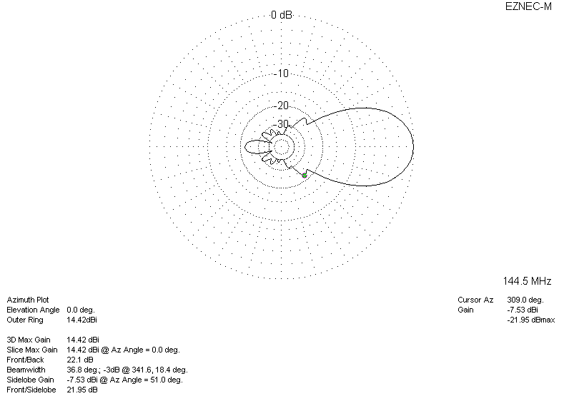
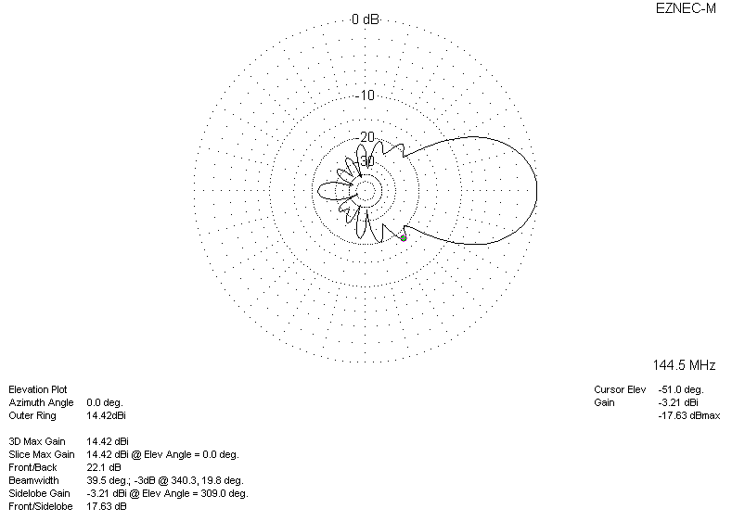
DIAGRAMS (losses included)
