ANTENNA Q209D6XL
PERFORMANCES: (No loss condition)
TYPE | ELE | L (mm) | G (dBi) | F/B (dB) | F/Sh (dBi) | F/Sv (dBi) | Hor (◦) | Ver (◦) | Temp (◦K) | G/T (dB) | ΔF * (kHz)
Q209D6XL | 9 | 4345 | 14,25 | 20,28 | 22,97 | 18,33 | 37,6 | 40,7 | 234,1 | -9,44 | 3830
* ΔF given for SWR=1,5

PERFORMANCES: (Losses included)
Element material | G (dBi) | Temp (◦K) | G/T (dB)
Aluminum rods | 14,17 | 235,2 | -9,54

DIMENSIONS:
 | Ref | De | D1 | D2 | D3 | D4 | D5 | D6 | D7
Pos | 0 | 382 | 565 | 925 | 1409 | 1972 | 2735 | 3569 | 4345
Length | 792 | 736 | 712 | 680 | 666 | 648 | 632 | 620 | 610

REMARKS: : - All elements made of Al rods Ǿ5 mm
- The height of all rectangles is 320 mm
- All dimensions given in milimetres

COMPARISON
Antenna | Boomlength (mm) | Material | Gain (dBi) | TA (◦K) | G/T (dB) | Bandwidth  (MHz)
Q209D6XL | 4345 | No loss | 14,25 | 234,1 | -9,44 | 143,500-147,330
Q209D6XL | 4345 | Aluminum | 14,17 | 235,2 | -9,54 | 143,500-147,330
EF0209-5 | 4490 | No loss | 14,06 | 239,8 | -9,74 | 140,100-145,480
EF0209-5 | 4490 | Aluminum | 13,99 | 240,9 | -9,83 | 140,100-145,480

DIAGRAMS (no loss included)
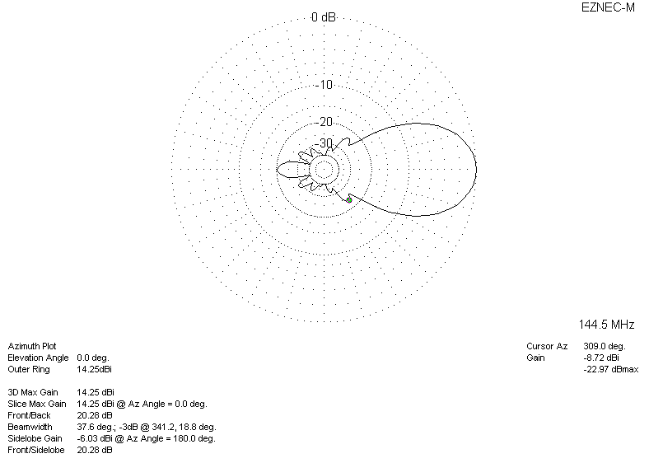
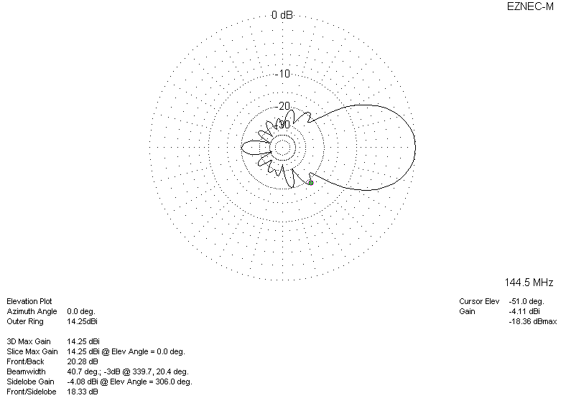
LOSS INCLUDED
