ANTENNA Q209D4XL
PERFORMANCES: (No loss condition)
TYPE | ELE | L (mm) | G (dBi) | F/B (dB) | F/Sh (dBi) | F/Sv (dBi) | Hor (◦) | Ver (◦) | Temp (◦K) | G/T (dB) | ΔF * (kHz)
Q209D4XL | 9 | 4245 | 14,30 | 22,18 | 22,79 | 18,17 | 37,4 | 40,3 | 234,7 | -9,41 | 1470
* ΔF given for SWR=1,5

PERFORMANCES: (Losses included)
Element material | G (dBi) | Temp (◦K) | G/T (dB)
Aluminum rods | 14,21 | 236,0 | -9,52

DIMENSIONS:
 | Ref | De | D1 | D2 | D3 | D4 | D5 | D6 | D7 | - All elements made of Al rods Ǿ5 mm  - The height of all rectangles is 320 mm  - All dimensions given in milimeters
Pos | 0 | 335 | 488 | 789 | 1115 | 1751 | 2589 | 3428 | 4245
Length | 786 | 730 | 710 | 672 | 666 | 660 | 636 | 622 | 610

COMPARISON
Antenna | Boomlength (mm) | Material | Gain (dBi) | TA (◦K) | G/T (dB) | Bandwidth  (MHz)
Q209D4XL | 4245 | No loss | 14,30 | 234,7 | -9,41 | 143,770-145,240
Q209D4XL | 4245 | Aluminum | 14,21 | 236,0 | -9,52 | 143,770-145,240
EF0208-5 | 3900 | No loss | 13,52 | 248,2 | -10,43 | 141,220-145,490
EF0208-5 | 3900 | Aluminum | 13,45 | 249,2 | -10,51 | 141,220-145,490

DIAGRAMS (no loss included)
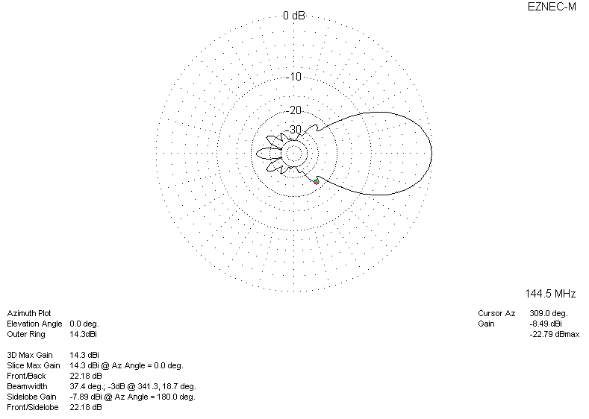
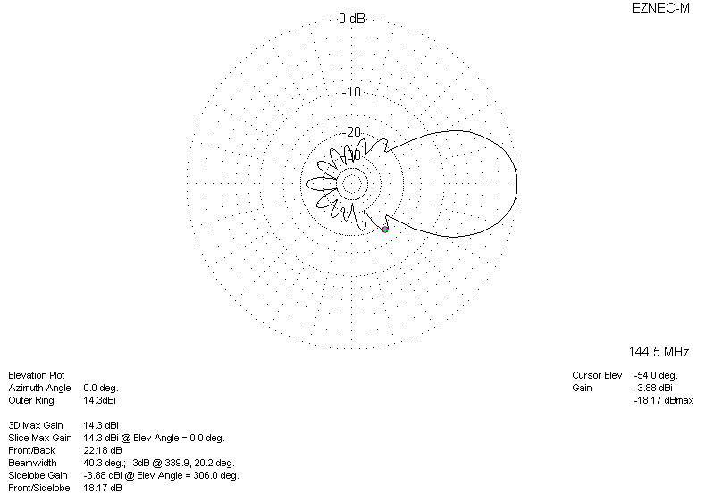
DIAGRAMS (losses included)
