ANTENNA Q209D3XL
PERFORMANCES: (No loss condition)
TYPE | ELE | L (mm) | G (dBi) | F/B (dB) | F/Sh (dBi) | F/Sv (dBi) | Hor (◦) | Ver (◦) | Temp (◦K) | G/T (dB) | ΔF * (kHz)
Q209D3XL | 9 | 4430 | 14,32 | 19,41 | 22,30 | 17,80 | 37,0 | 39,8 | 237,2 | -9,43 | 3320
* ΔF given for SWR=1,5

PERFORMANCES: (Losses included)
Element material | G (dBi) | Temp (◦K) | G/T (dB)
Aluminum rods | 14,23 | 238,6 | -9,55

DIMENSIONS:
 | Ref | De | D1 | D2 | D3 | D4 | D5 | D6 | D7 | - All elements made of Al rods Ǿ5 mm  - The height of all rectangles is 320 mm  - All dimensions given in milimeters
Pos | 0 | 393 | 590 | 928 | 1426 | 2055 | 2845 | 3675 | 4430
Length | 790 | 748 | 720 | 680 | 674 | 658 | 638 | 624 | 618

COMPARISON
Antenna | Boomlength (mm) | Material | Gain (dBi) | TA (◦K) | G/T (dB)
Q209D3XL | 4430 | No loss | 14,32 | 237,2 | -9,43
Q209D3XL | 4430 | Aluminum | 14,23 | 238,6 | -9,55
EF0208-5 | 3900 | No loss | 13,52 | 248,2 | -10,43
EF0208-5 | 3900 | Aluminum | 13,45 | 249,2 | -10,51

DIAGRAMS (no loss included)
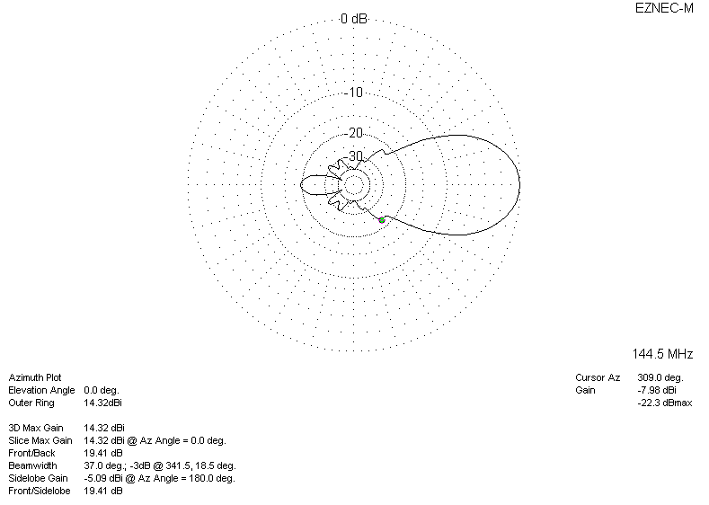
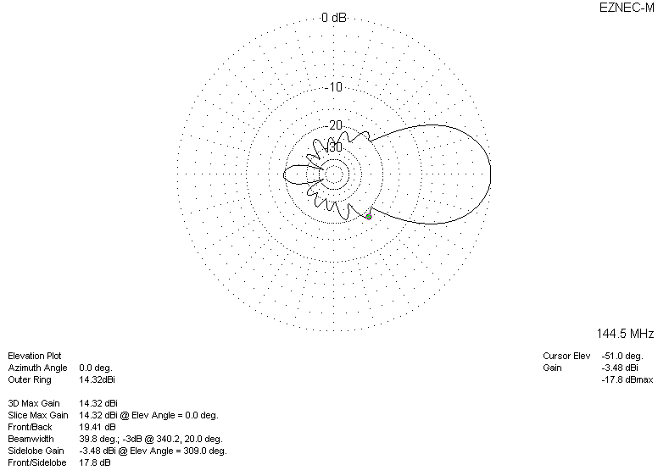
DIAGRAMS (losses included)
