ANTENNA Q209C2XL
PERFORMANCES: (No loss condition)
TYPE | ELE | L (mm) | G (dBi) | F/B (dB) | F/Sh (dBi) | F/Sv (dBi) | Hor (◦) | Ver (◦) | Temp (◦K) | G/T (dB) | ΔF * (kHz)
Q209C2XL | 9 | 5492 | 14,80 | 22,22 | 24,11 | 20,10 | 36,0 | 38,5 | 226,7 | -8,76 | 3040
* ΔF given for SWR=1,5

PERFORMANCES: (Losses included)
Element material | G (dBi) | Temp (◦K) | G/T (dB)
Aluminum rods | 14,72 | 228,1 | -8,86

DIMENSIONS:
 | Ref | De | D1 | D2 | D3 | D4 | D5 | D6 | D7 | - All elements made of Al rods Ǿ5 mm  - The height of all rectangles is 300 mm  - All dimensions given in milimeters
Pos | 0 | 322 | 678 | 1294 | 2042 | 2837 | 3679 | 4532 | 5492
Length | 806 | 752 | 726 | 690 | 668 | 648 | 624 | 602 | 588

COMPARISON
Antenna | Boomlength (mm) | Material | Gain (dBi) | TA (◦K) | G/T (dB) | Bandwidth  (MHz)
Q209C2XL | 5492 | No loss | 14,80 | 226,7 | -8,76 | 143,200-146,160
Q209C2XL | 5492 | Aluminum | 14,72 | 228,1 | -8,86 | 143,200-146,160
EF0210-5 | 5290 | No loss | 14,77 | 233,8 | -8,92 | 140,190-145,450
EF0210-5 | 5290 | Aluminum | 14,67 | 235,4 | -9,05 | 140,190-145,450

DIAGRAMS (no loss included)
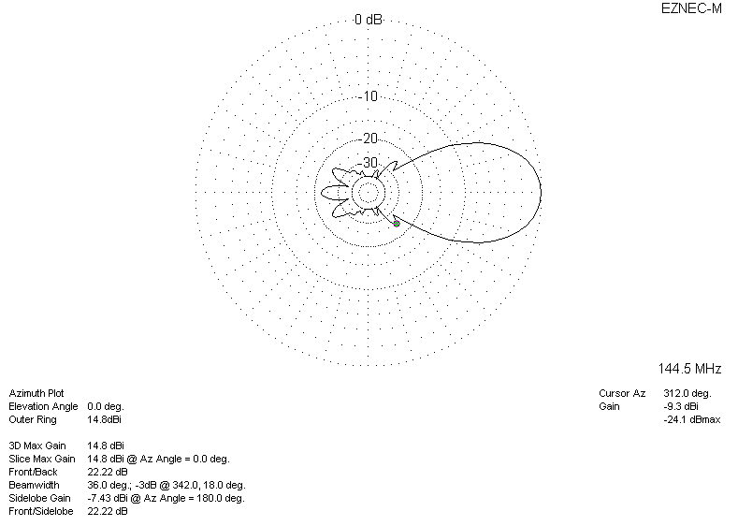
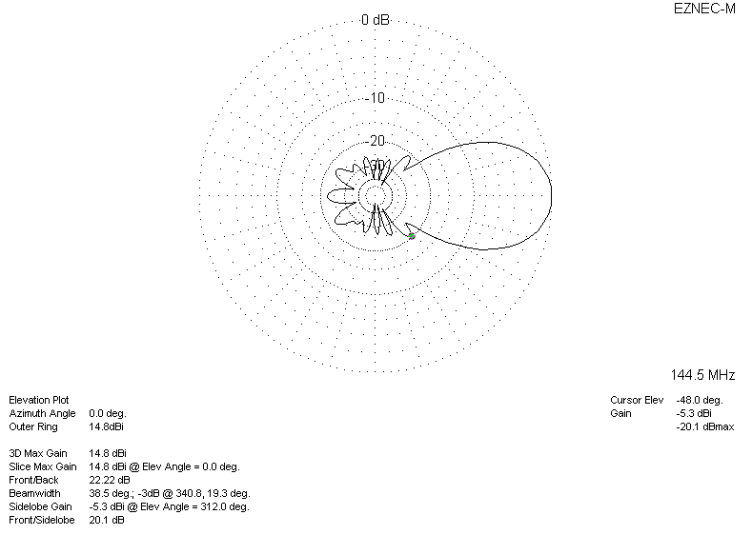
DIAGRAMS (losses included)
