ANTENNA Q209C1XL
PERFORMANCES: (No loss condition)
TYPE | ELE | L (mm) | G (dBi) | F/B (dB) | F/Sh (dBi) | F/Sv (dBi) | Hor (◦) | Ver (◦) | Temp (◦K) | G/T (dB) | ΔF * (kHz)
Q209C1XL | 9 | 5355 | 14,90 | 20,56 | 22,59 | 18,69 | 35,4 | 37,9 | 224,4 | -8,61 | 2950
* ΔF given for SWR=1,5

PERFORMANCES: (Losses included)
Element material | G (dBi) | Temp (◦K) | G/T (dB)
Aluminum rods | 14,82 | 225,9 | -8,72

DIMENSIONS:
 | Ref | De | D1 | D2 | D3 | D4 | D5 | D6 | D7 | - All elements made of Al rods Ǿ5 mm  - The height of all rectangles is 300 mm  - All dimensions given in milimeters
Pos | 0 | 305 | 655 | 1275 | 1976 | 2788 | 3649 | 4535 | 5355
Length | 806 | 749 | 728 | 692 | 670 | 652 | 630 | 610 | 600

COMPARISON
Antenna | Boomlength (mm) | Material | Gain (dBi) | TA (◦K) | G/T (dB) | Bandwidth  (MHz)
Q209XLS | 5355 | No loss | 14,90 | 224,4 | -8,61 | 143,300-146,050
Q209XLS | 5355 | Aluminum | 14,82 | 225,9 | -8,72 | 143,300-146,050
EF0210-5 | 5290 | No loss  Aluminum | 14,77 | 233,8 | -8,92 | 140,190-145,450
EF0210-5 | 5290 | No loss  Aluminum | 14,67 | 235,4 | -9,05 | 140,190-145,450

DIAGRAMS (no loss included)
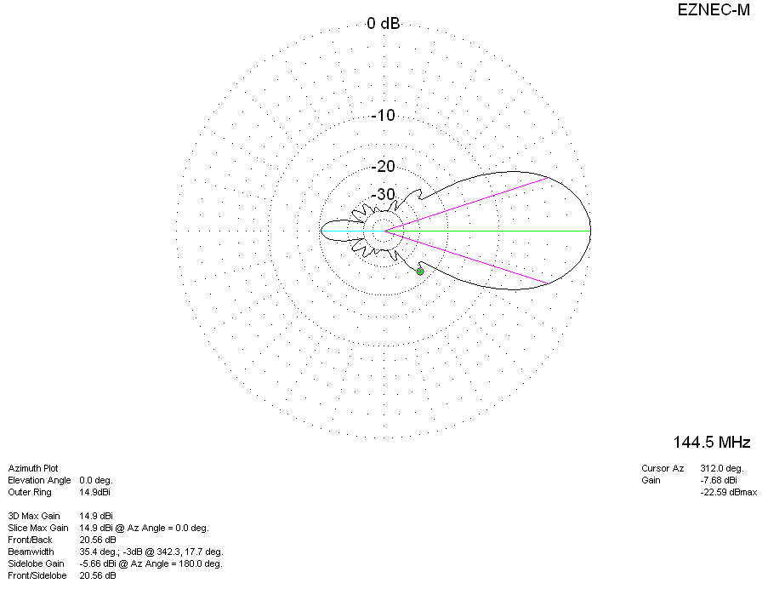
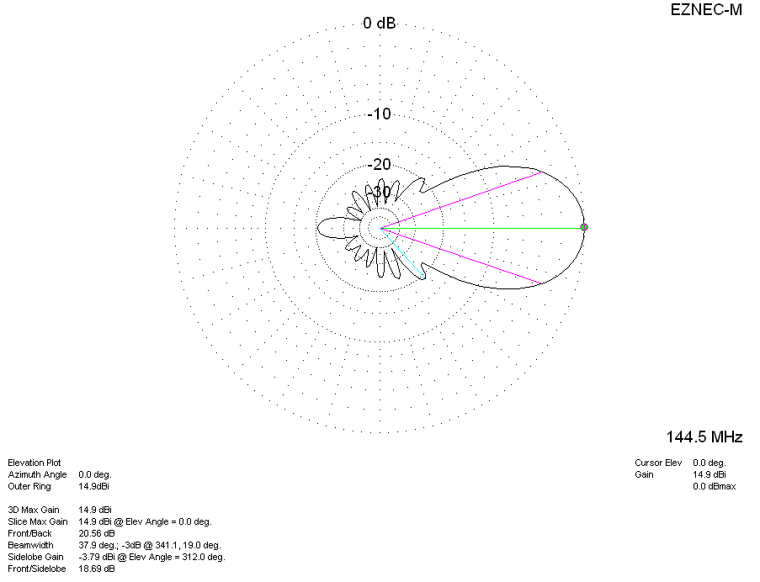
DIAGRAMS (losses included)
