ANTENNA Q208H3XL
PERFORMANCES: (No loss condition)
TYPE | ELE | L (mm) | G (dBi) | F/B (dB) | F/Sh (dBi) | F/Sv (dBi) | Hor (◦) | Ver (◦) | Temp (◦K) | G/T (dB) | ΔF * (kHz)
Q208H3XL | 8 | 4705 | 14,43 | 21,50 | 21,69 | 18,48 | 37,4 | 39,2 | 238,7 | -9,35 | 2800
* ΔF given for SWR=1,5

PERFORMANCES: (Losses included)
Element material | G (dBi) | Temp (◦K) | G/T (dB)
Aluminum rods | 14,29 | 240,7 | 9,53

DIMENSIONS:
 | Ref | De | D1 | D2 | D3 | D4 | D5 | D6 | REMARKS: - All elements made of Al rods Ǿ3 mm  - The height of all rectangles is 500 mm  - All dimensions given in milimetres
Pos | 0 | 398 | 778 | 1398 | 2163 | 2985 | 3790 | 4705
Length | 612 | 574 | 554 | 540 | 521 | 502 | 492 | 480

COMPARISON
Antenna | Boomlength (mm) | Material | Gain (dBi) | TA (◦K) | G/T (dB) | Bandwidth  (MHz)
Q208H3XL | 4705 | No loss | 14,43 | 238,7 | -9,35 | 143,100-145,900
Q208H3XL | 4705 | Aluminum | 14,29 | 240,7 | -9,53 | 143,100-145,900
EF0210-5LT | 5190 | No loss | 14,12 | 224,1 | -9,38 | 142,000-145,790
EF0210-5LT | 5190 | Aluminum | 14,01 | 226,0 | -9,53 | 142,000-145,790

DIAGRAMS (no loss included)

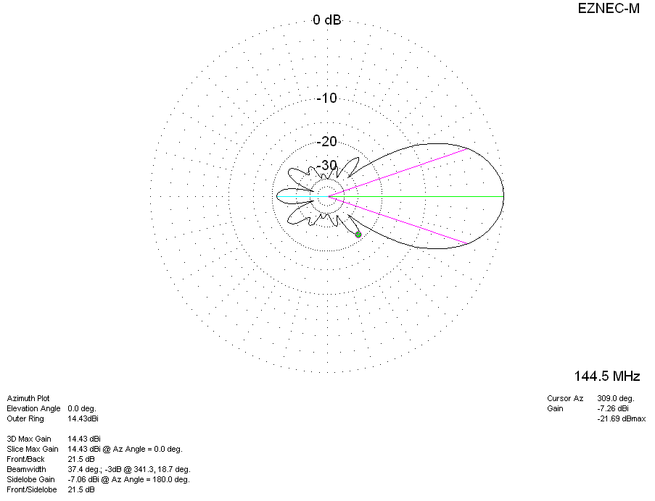
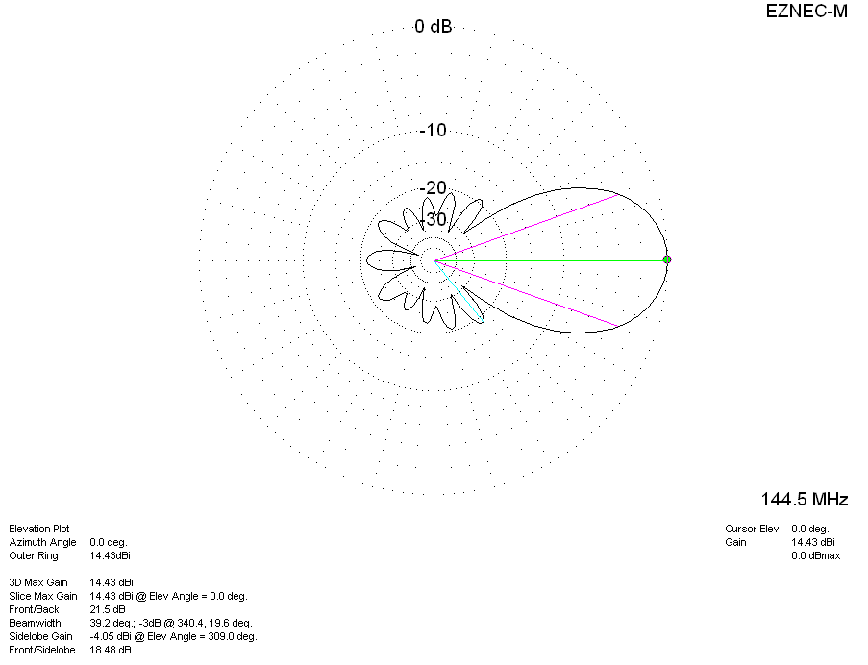

LOSSES INCLUDED
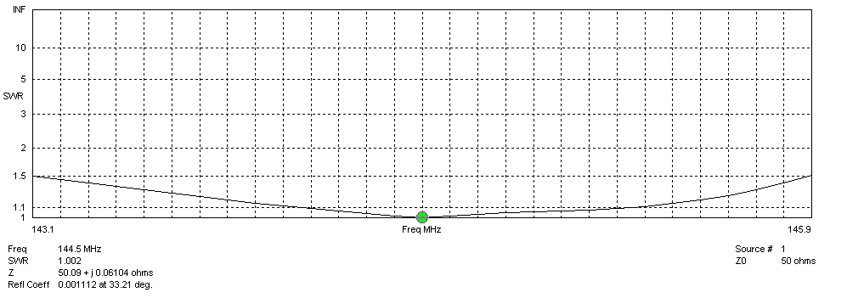
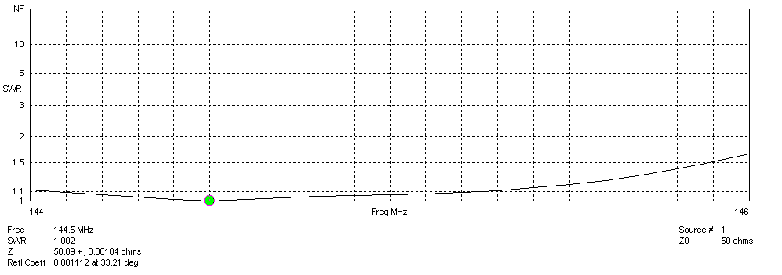
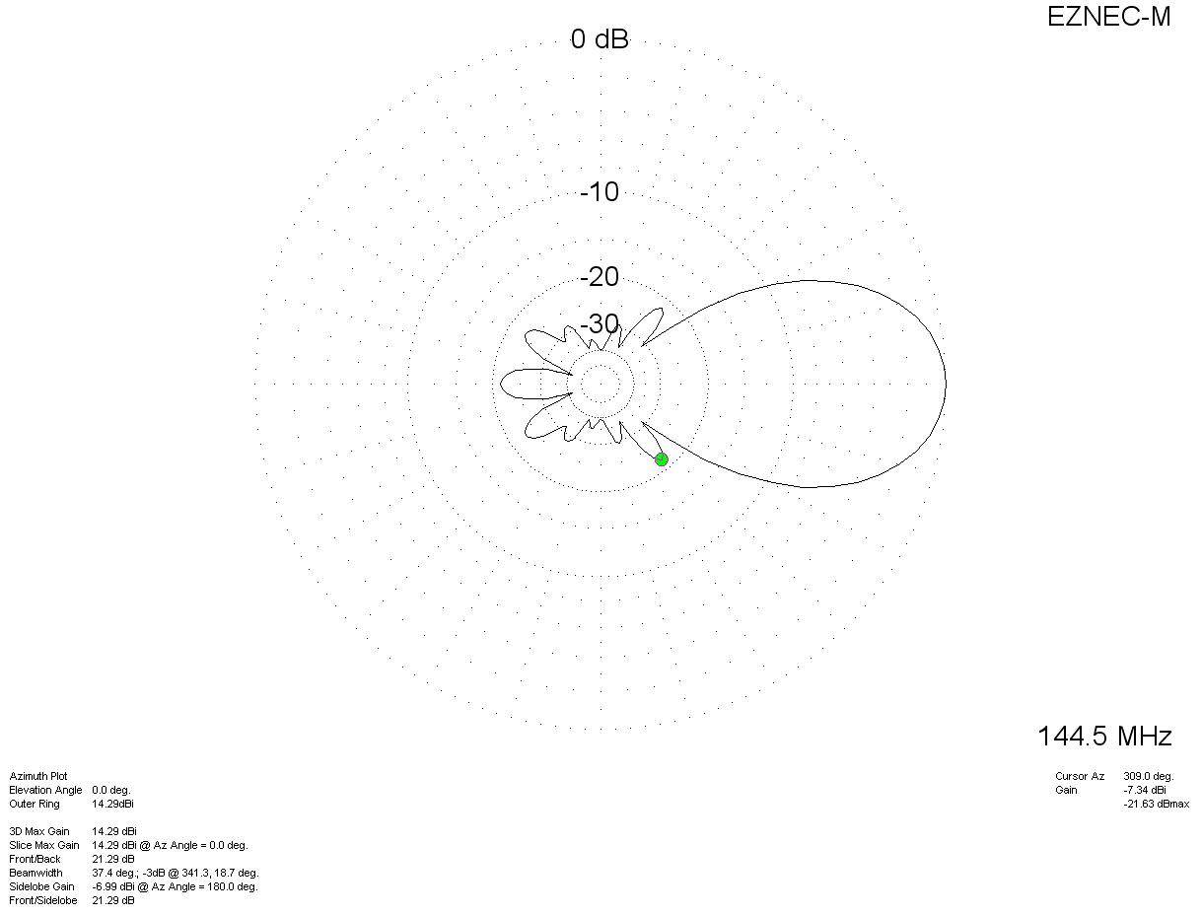
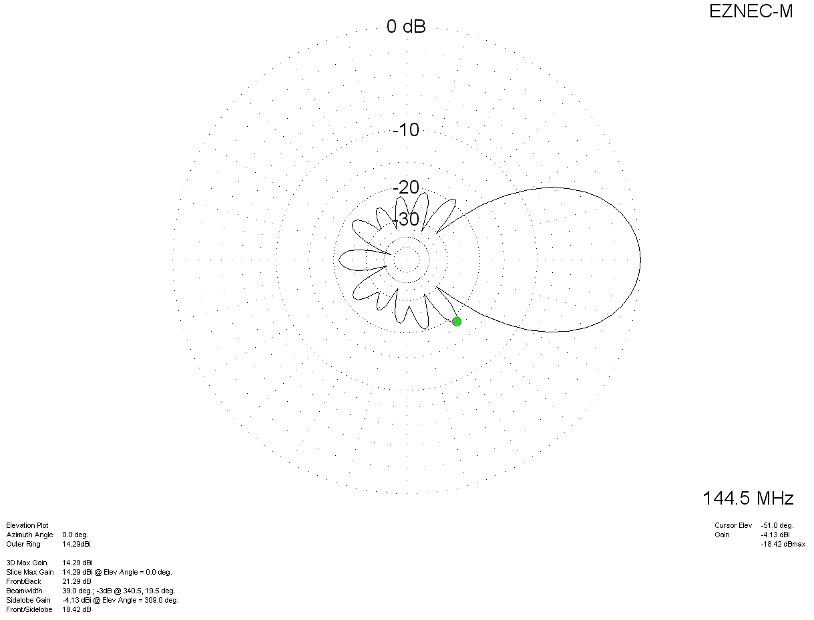
STACKING: 4 antennas in H-configuration H=315 cm, V=345 cm

PERFORMANCES:
Element material | G (dBi) | Temp (◦K) | G/T (dB)
No loss | 20,37 | 241,4 | -346
Aluminum rods | 20,23 | 243,0 | -3,63

NO LOSS CONDITION
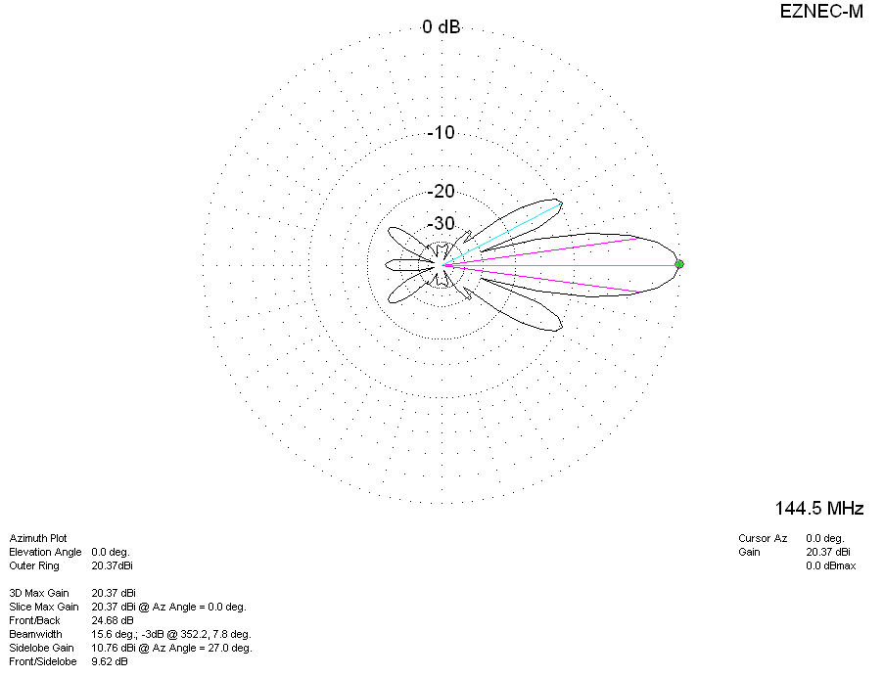
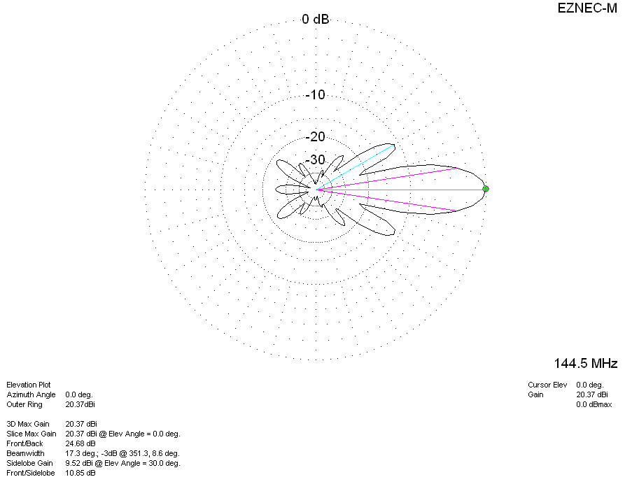
LOSSES INCLUDED
