ANTENNA Q208E2XL
PERFORMANCES:
TIP | ELE | L (mm) | G (dBi) | F/B (dB) | F/Sh (dBi) | F/Sv (dBi) | Hor (◦) | Ver (◦) | Temp (◦K) | G/T (dB) | ΔF * (MHz)
Q208E2XL | 8 | 3680 | 13,65 | 20,30 | 23,56 | 18,28 | 40,6 | 43,8 | 241,8 | -10,18 | 3,700
* ΔF given for SWR=1,5

PERFORMANCES: (Losses included)
Element material | G (dBi) | Temp (◦K) | G/T (dB)
Aluminum rods | 13,58 | 242,7 | -10,27

DIMENSIONS:
 | Ref | De | D1 | D2 | D3 | D4 | D5 | D6 | REMARKS: - All elements made of Al rods Ǿ5 mm  - The width of all rectangles is 400 mm  - All dimensions given in milimetres
Pos | 0 | 320 | 555 | 952 | 1495 | 2195 | 2945 | 3675
Length | 716 | 670 | 644 | 622 | 586 | 574 | 566 | 562

COMPARISON
Antenna | Boomlength (mm) | Material | Gain (dBi) | TA (◦K) | G/T (dB) | Bandwidth  (MHz)
Q208E2XL | 3680 | No loss | 13,65 | 241,8 | -10,18 | 142,600-146,300
Q208E2XL | 3680 | Aluminum | 13,58 | 242,7 | -10,27 | 142,600-146,300
EF0207-5 | 3274 | No loss | 12,95 | 255,9 | -11,13 | 140,500-145,100
EF0207-5 | 3274 | Aluminum | 12,86 | 256,8 | -11,25 | 140,500-145,100
EF0208-5 | 3900 | No loss | 13,52 | 248,2 | -10,43 | 141,220-145,490
EF0208-5 | 3900 | Aluminum | 13,42 | 249,2 | -10,51 | 141,220-145,490

DIAGRAMS (no loss included)

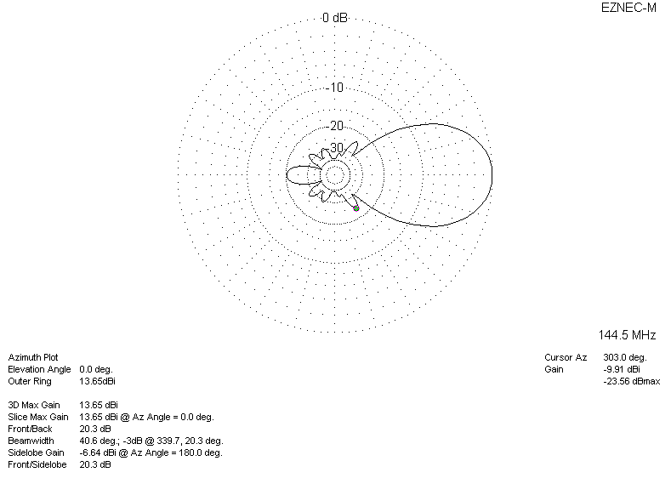
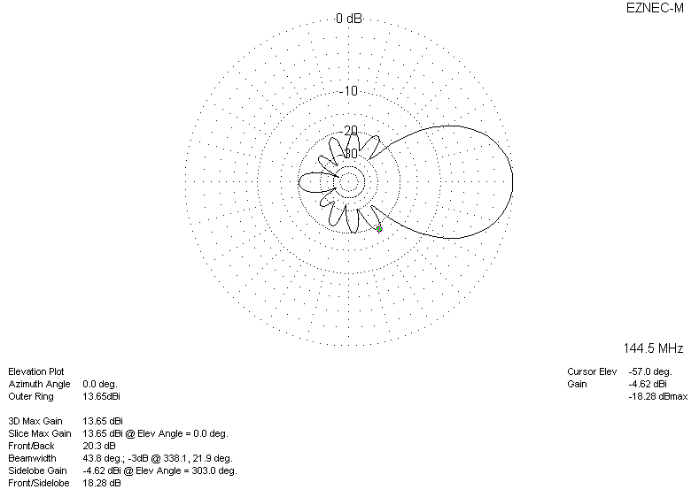
DIAGRAMS (losses included)
