ANTENNA Q208E1XL
PERFORMANCES:
TIP | ELE | L (mm) | G (dBi) | F/B (dB) | F/Sh (dBi) | F/Sv (dBi) | Hor (◦) | Ver (◦) | Temp (◦K) | G/T (dB) | ΔF * (MHz)
Q208E1XL | 8 | 4360 | 14,52 | 20,79 | 20,99 | 17,05 | 36,6 | 38,7 | 238,4 | -9,25 | 2,230
* ΔF given for SWR=1,5

PERFORMANCES: (Losses included)
Element material | G (dBi) | Temp (◦K) | G/T (dB)
Aluminum rods | 14,41 | 239,8 | -9,39

DIMENSIONS:
 | Ref | De | D1 | D2 | D3 | D4 | D5 | D6 | REMARKS: - All elements made of Al rods Ǿ5 mm  - The width of all rectangles is 400 mm  - All dimensions given in milimetres
Pos | 0 | 327 | 548 | 1109 | 1879 | 2691 | 3567 | 4360
Length | 708 | 670 | 651 | 622 | 598 | 582 | 574 | 564

COMPARISON
Antenna | Boomlength (mm) | Material | Gain (dBi) | TA (◦K) | G/T (dB) | Bandwidth  (MHz)
Q208E1XL | 4360 | No loss | 14,52 | 238,4 | -9,25 | 143,300-145,530
Q208E1XL | 4360 | Aluminum | 14,41 | 239,8 | -9,39 | 143,300-145,530
EF0208-5 | 3900 | No loss | 13,52 | 248,2 | -10,43 | 141,220-145,490
EF0208-5 | 3900 | Aluminum | 13,42 | 249,2 | -10,51 | 141,220-145,490

DIAGRAMS (no loss included)

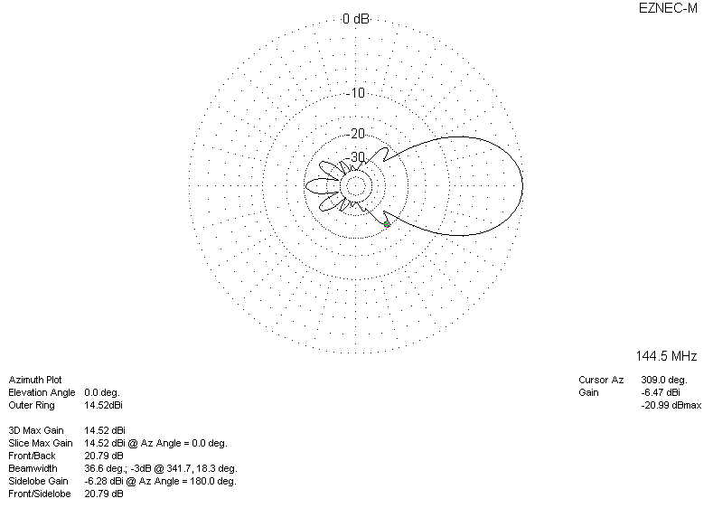
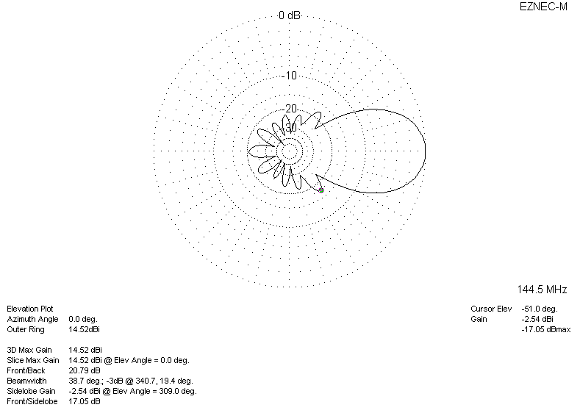
DIAGRAMS (losses included)
