ANTENNA Q208D1XL
PERFORMANCES:
TIP | ELE | L (mm) | G (dBi) | F/B (dB) | F/Sh (dBi) | F/Sv (dBi) | Hor (◦) | Ver (◦) | Temp (◦K) | G/T (dB) | ΔF * (MHz)
Q208D1XL | 8 | 3460 | 13,47 | 18,11 | 23,11 | 17,60 | 40,4 | 44,3 | 248,3 | -10,48 | 3,220
* ΔF given for SWR=1,5

PERFORMANCES: (Losses included)
Element material | G (dBi) | Temp (◦K) | G/T (dB)
Aluminum rods | 13,38 | 249,3 | -10,59

DIMENSIONS:
 | Ref | De | D1 | D2 | D3 | D4 | D5 | D6 | REMARKS: - All elements made of Al rods Ǿ5 mm  - The width of all rectangles is 320 mm  - All dimensions given in milimetres
Pos | 0 | 383 | 546 | 917 | 1404 | 1966 | 2719 | 3460
Length | 788 | 746 | 721 | 685 | 670 | 653 | 636 | 618

COMPARISON
Antenna | Boomlength (mm) | Material | Gain (dBi) | TA (◦K) | G/T (dB) | Bandwidth  (MHz)
Q208D1XL | 3460 | No loss | 13,47 | 248,3 | -10,48 | 142,610-145,930
Q208D1XL | 3460 | Aluminum | 13,38 | 249,3 | -10,59 | 142,610-145,930
EF0207-5 | 3274 | No loss | 12,95 | 255,9 | -11,13 | 140,500-145,100
EF0207-5 | 3274 | Aluminum | 12,86 | 256,8 | -11,25 | 140,500-145,100
EF0208-5 | 3900 | No loss | 13,52 | 248,2 | -10,43 | 141,220-145,490
EF0208-5 | 3900 | Aluminum | 13,42 | 249,2 | -10,51 | 141,220-145,490

DIAGRAMS (no loss included)

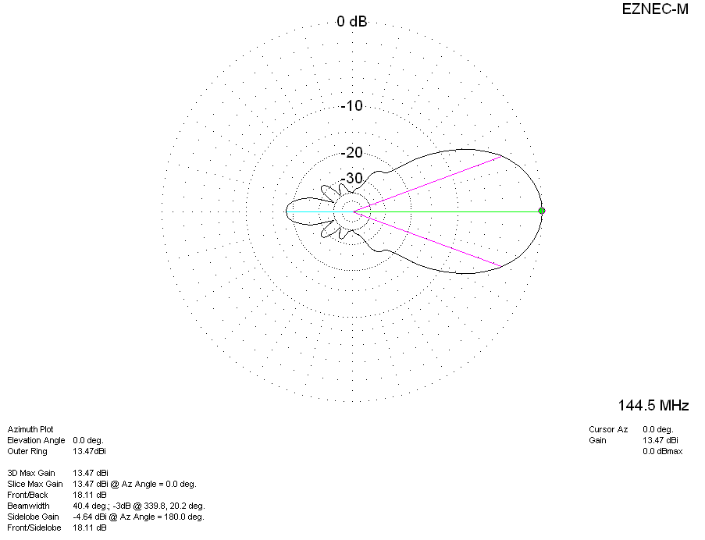
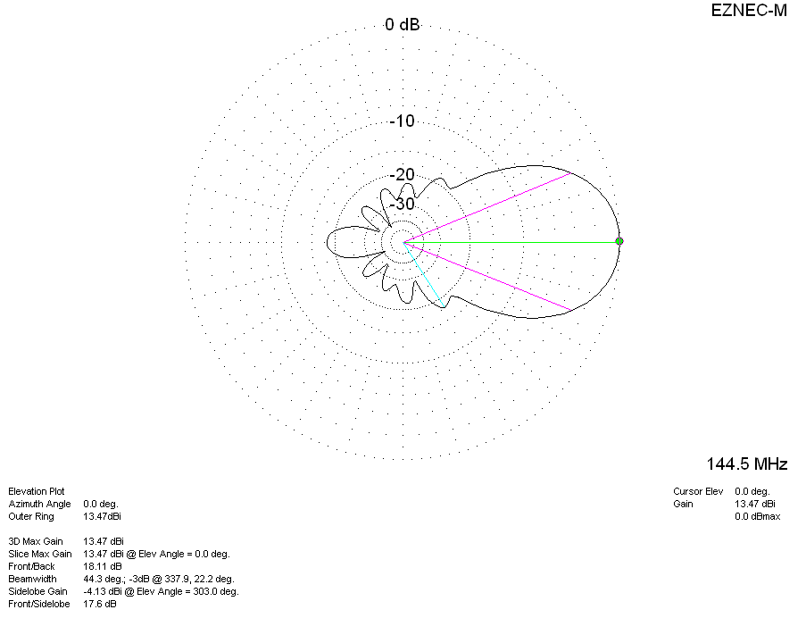
DIAGRAMS (losses included)
