ANTENNA Q208C2XL
PERFORMANCES: (No loss condition)
TYPE | ELE | L (mm) | G (dBi) | F/B (dB) | F/Sh (dBi) | F/Sv (dBi) | Hor (◦) | Ver (◦) | Temp (◦K) | G/T (dB) | ΔF * (kHz)
Q208C2XL | 8 | 4513 | 14,23 | 21,76 | 24,58 | 19,77 | 38,0 | 41,3 | 231,2 | -9,41 | 2900
* ΔF given for SWR=1,5

PERFORMANCES: (Losses included)
Element material | G (dBi) | Temp (◦K) | G/T (dB)
Aluminum rods | 14,15 | 232,4 | -9,51

DIMENSIONS:
 | Ref | De | D1 | D2 | D3 | D4 | D5 | D6 | REMARKS: : - All elements made of Al rods Ǿ5 mm  - The height of all rectangles is 300 mm  - All dimensions given in milimetres
Pos | 0 | 325 | 682 | 1295 | 2049 | 2835 | 3685 | 4513
Length | 808 | 754 | 727 | 690 | 666 | 638 | 618 | 608

COMPARISON
Antenna | Boomlength (mm) | Material | Gain (dBi) | TA (◦K) | G/T (dB) | Bandwidth  (MHz)
Q208C2XL | 4513 | No loss | 14,23 | 232,9 | -9,33 | 142,900-145,800
Q208C2XL | 4513 | Aluminum | 14,15 | 234,2 | -9,45 | 142,900-145,800
EF0208-5 | 3900 | No loss | 13,52 | 248,2 | -10,43 | 141,220-145,490
EF0208-5 | 3900 | Aluminum | 13,45 | 249,2 | -10,51 | 141,220-145,490

DIAGRAMS (no loss included)
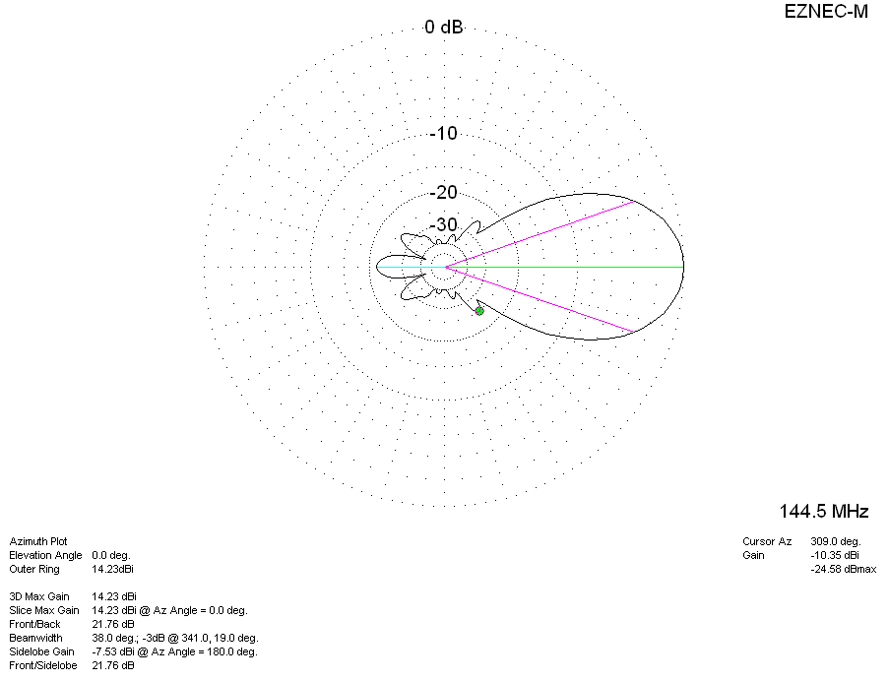
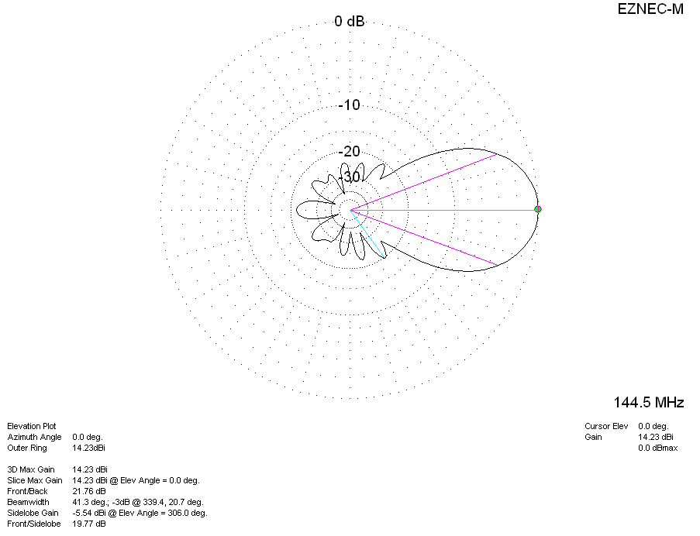
DIAGRAMS (losses included)
