ANTENNA Q207H1XL
PERFORMANCES: (No loss condition)
TYPE | ELE | L (mm) | G (dBi) | F/B (dB) | F/Sh (dBi) | F/Sv (dBi) | Hor (◦) | Ver (◦) | Temp (◦K) | G/T (dB) | ΔF * (kHz)
Q207H1XL | 7 | 3686 | 13,69 | 19,98 | 23,50 | 19,16 | 40,6 | 43,0 | 243,5 | -10,17 | 3570
* ΔF given for SWR=1,5

PERFORMANCES: (Losses included)
Element material | G (dBi) | Temp (◦K) | G/T (dB)
Aluminum rods | 13,59 | 244,8 | -10,33

DIMENSIONS:
 | Ref | De | D1 | D2 | D3 | D4 | D5 | REMARKS: : - All elements made of Al rods Ǿ5 mm  - The height of all rectangles is 500 mm  - All dimensions given in milimetres
Pos | 0 | 362 | 654 | 1218 | 2039 | 2865 | 3686
Length | 630 | 585 | 564 | 542 | 512 | 494 | 486

COMPARISON
Antenna | Boomlength (mm) | Material | Gain (dBi) | TA (◦K) | G/T (dB) | BEAMWIDTH  (MHz)
Q207H1XL | 3686 | No loss | 13,69 | 243,5 | -10,17 | 141,800-145,370
Q207H1XL | 3686 | Aluminum | 13,59 | 244,8 | -10,33 | 141,800-145,370
EF0207-5 | 3274 | No loss | 12,95 | 255,9 | -11,13 | 140,500-145,100
EF0207-5 | 3274 | Aluminum | 12,86 | 256,8 | -11,25 | 140,500-145,100

DIAGRAMS (no loss included)
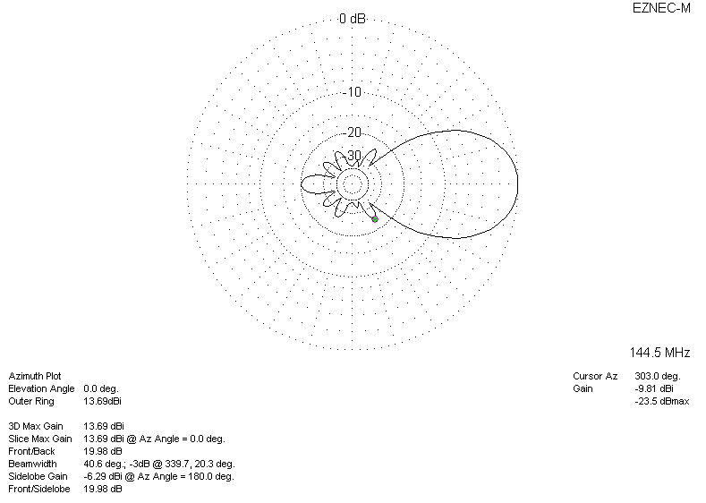
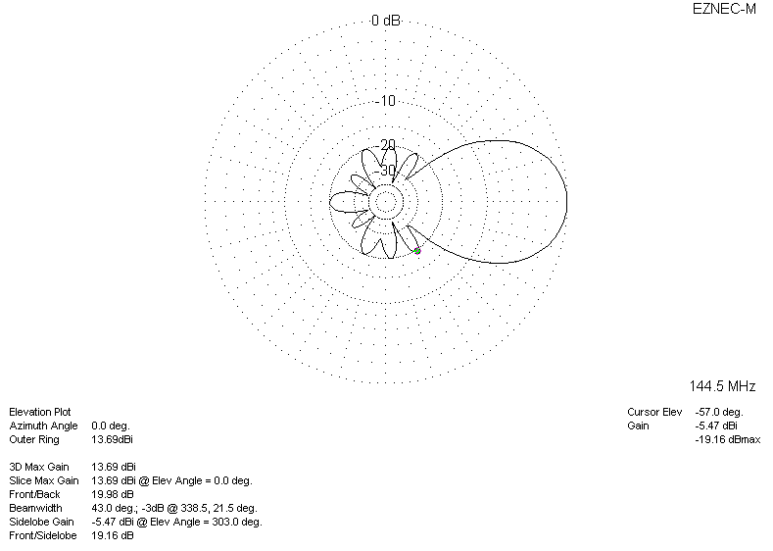
DIAGRAMS (losses included)
