ANTENNA Q207Q3XL
PERFORMANCES: (No loss condition)
TYPE | ELE | L (mm) | G (dBi) | F/B (dB) | F/Sh (dBi) | F/Sv (dBi) | Hor (◦) | Ver (◦) | Temp (◦K) | G/T (dB) | ΔF * (kHz)
Q207G3XL | 7 | 3765 | 13,76 | 18,43 | 22,77 | 18,50 | 40,4 | 42,7 | 242,1 | -10,08 | 3120
* ΔF given for SWR=1,5

PERFORMANCES: (Losses included)
Element material | G (dBi) | Temp (◦K) | G/T (dB)
Aluminum rods | 13,68 | 243,3 | -10,18

DIMENSIONS:
 | Ref | De | D1 | D2 | D3 | D4 | D5 | REMARKS: : - All elements made of Al rods Ǿ5 mm  - The height of all rectangles is 500 mm  - All dimensions given in milimetres
Pos | 0 | 411 | 789 | 1391 | 2158 | 2956 | 3765
Length | 624 | 578 | 561 | 538 | 516 | 494 | 482

COMPARISON
Antenna | Boomlength (mm) | Material | Gain (dBi) | TA (◦K) | G/T (dB) | Beamwidth  (MHz)
Q207G3XL | 3765 | No loss | 13,76 | 242,1 | -10,08 | 142,600-145,720
Q207G3XL | 3765 | Aluminum | 13,68 | 243,3 | -10,18 | 142,600-145,720
EF0207-5 | 3274 | No loss | 12,95 | 255,9 | -11,13 | 140,500-145,100
EF0207-5 | 3274 | Aluminum | 12,86 | 256,8 | -11,25 | 140,500-145,100
EF0208-5 | 3900 | No loss | 13,52 | 248,2 | -10,43 | 141,220-145,490
EF0208-5 | 3900 | Aluminum | 13,42 | 249,2 | -10,51 | 141,220-145,490

DIAGRAMS (no loss included)

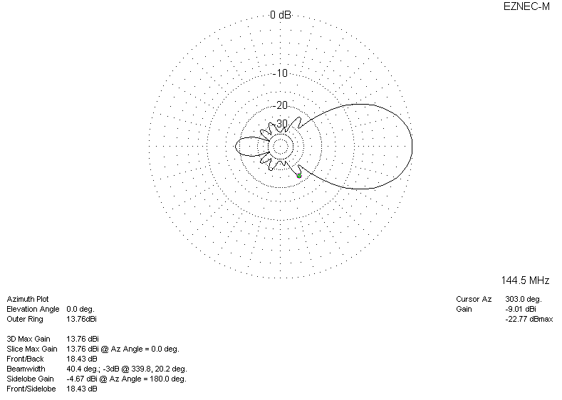
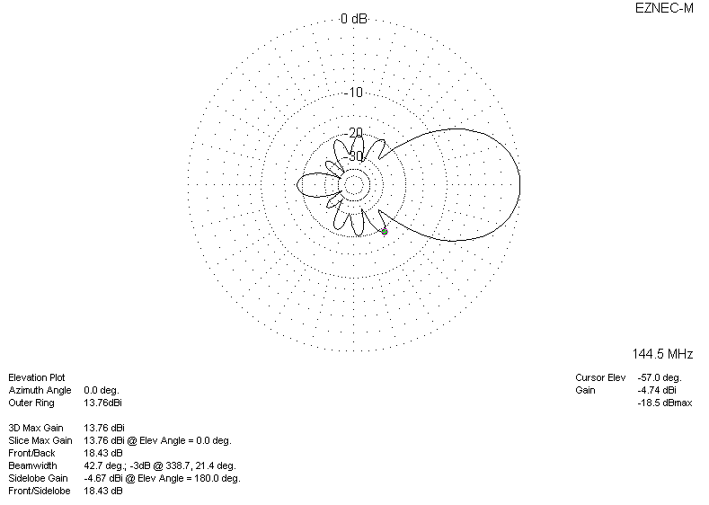
DIAGRAMS (losses included)
