ANTENNA Q 207G1XL
PERFORMANCES: (No loss condition)
TYPE | ELE | L (mm) | G (dBi) | F/B (dB) | F/Sh (dBi) | F/Sv (dBi) | Hor (◦) | Ver (◦) | Temp (◦K) | G/T (dB) | ΔF * (kHz)
Q207G1XL | 7 | 3753 | 13,78 | 20,73 | 22,27 | 18,09 | 40,2 | 42,5 | 242,3 | -10,06 | 3030
* ΔF given for SWR=1,5

PERFORMANCES: (Losses included)
Element material | G (dBi) | Temp (◦K) | G/T (dB)
Aluminum rods | 13,69 | 243,5 | -10,17

DIMENSIONS:
 | Ref | De | D1 | D2 | D3 | D4 | D5 | REMARKS: : - All elements made of Al rods Ǿ3 mm  - The height of all rectangles is 500 mm  - All dimensions given in milimetres
Pos | 0 | 401 | 789 | 1395 | 2162 | 2975 | 3753
Length | 616 | 578 | 558 | 542 | 520 | 498 | 484

COMPARISON
Antenna | Boomlength (mm) | Material | Gain (dBi) | TA (◦K) | G/T (dB) | BEAMWIDTH  (MHz)
Q207G1XL | 3753 | No loss | 13,78 | 242,3 | -10,06 | 142,310-145,340
Q207G1XL | 3753 | Aluminum | 13,69 | 243,5 | -10,17 | 142,310-145,340
EF0207-5 | 3274 | No loss | 12,95 | 255,9 | -11,13 | 140,500-145,100
EF0207-5 | 3274 | Aluminum | 12,86 | 256,8 | -11,25 | 140,500-145,100

DIAGRAMS (no loss included)
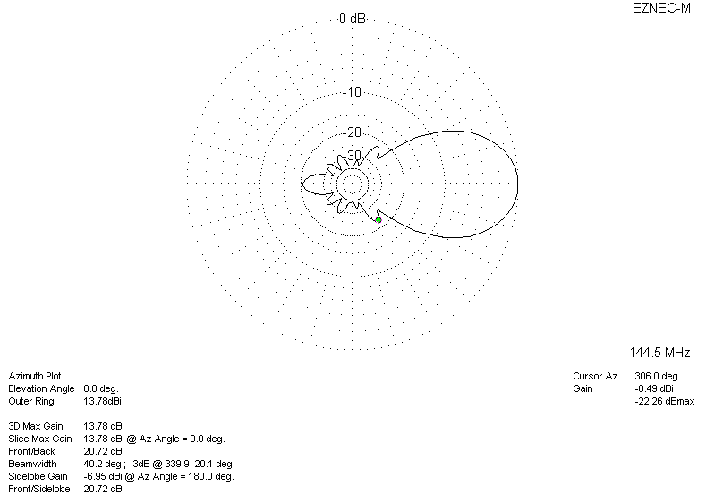
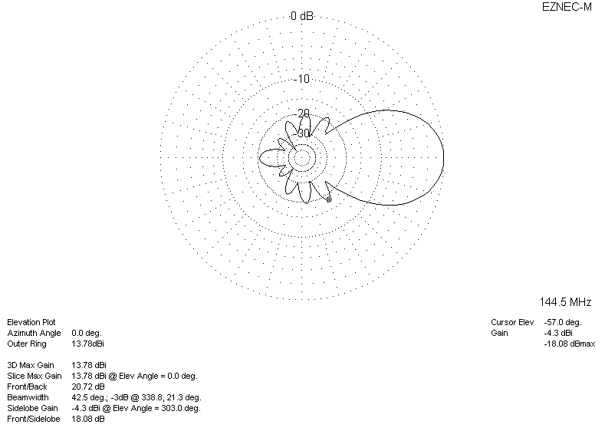
DIAGRAMS (losses included)
