ANTENNA Q207E1XL
PERFORMANCES: (No loss condition)
TYPE | ELE | L (mm) | G (dBi) | F/B (dB) | F/Sh (dBi) | F/Sv (dBi) | Hor (◦) | Ver (◦) | Temp (◦K) | G/T (dB) | ΔF * (kHz)
Q207E1XL | 7 | 3465 | 13,75 | 20,63 | 22,77 | 17,55 | 39,6 | 42,7 | 246,2 | -10,16 | 2830
* ΔF given for SWR=1,5

PERFORMANCES: (Losses included)
Element material | G (dBi) | Temp (◦K) | G/T (dB)
Aluminum rods | 13,65 | 247,3 | -10,28

DIMENSIONS:
 | Ref | De | D1 | D2 | D3 | D4 | D5 | REMARKS: : - All elements made of Al rods Ǿ5 mm  - The height of all rectangles is 400 mm  - All dimensions given in milimetres
Pos | 0 | 298 | 542 | 1110 | 1879 | 2685 | 3465
Length | 708 | 673 | 651 | 621 | 596 | 580 | 574

COMPARISON
Antenna | Boomlength (mm) | Material | Gain (dBi) | TA (◦K) | G/T (dB) | BEAMWIDTH  (MHz)
Q207E1XL | 3465 | No loss | 13,75 | 246,2 | -10,16 | 142,700-145,530
Q207E1XL | 3465 | Aluminum | 13,65 | 247,3 | -10,28 | 142,700-145,530
EF0207-5 | 3274 | No loss | 12,95 | 255,9 | -11,13 | 140,500-145,100
EF0207-5 | 3274 | Aluminum | 12,86 | 256,8 | -11,25 | 140,500-145,100

DIAGRAMS (no loss included)
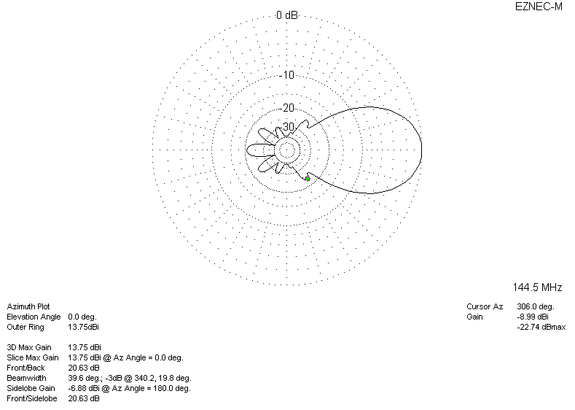
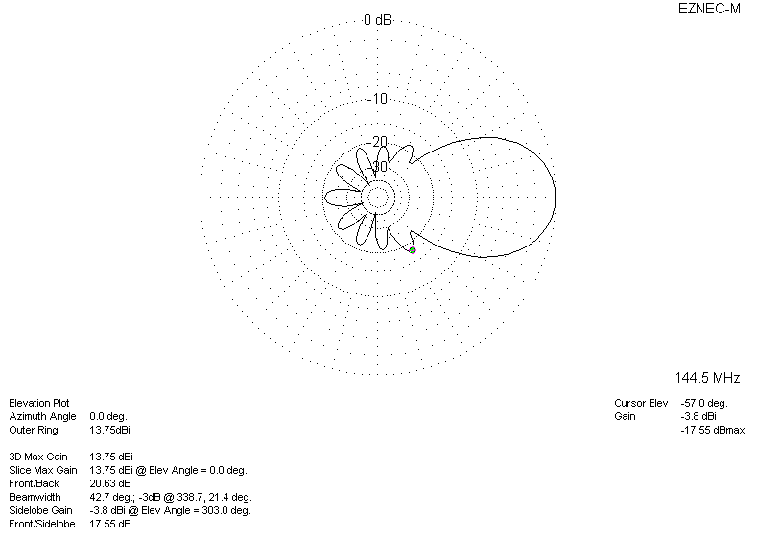
DIAGRAMS (losses included)
