ANTENNA Q207C3XL
PERFORMANCES: (No loss condition)
TYPE | ELE | L (mm) | G (dBi) | F/B (dB) | F/Sh (dBi) | F/Sv (dBi) | Hor (◦) | Ver (◦) | Temp (◦K) | G/T (dB) | ΔF * (kHz)
Q207C3XL | 7 | 3576 | 13,63 | 18,88 | 23,00 | 17,03 | 39,8 | 43,7 | 248,7 | -10,33 | 3250
* ΔF given for SWR=1,5

PERFORMANCES: (Losses included)
Element material | G (dBi) | Temp (◦K) | G/T (dB)
Aluminum rods | 13,54 | 249,6 | -10,43

DIMENSIONS:
 | Ref | De | D1 | D2 | D3 | D4 | D5 | REMARKS: : - All elements made of Al rods Ǿ5 mm  - The height of all rectangles is 300 mm  - All dimensions given in milimetres
Pos | 0 | 305 | 601 | 1247 | 1996 | 2727 | 3576
Length | 810 | 766 | 730 | 690 | 670 | 648 | 630

COMPARISON
Antenna | Boomlength (mm) | Material | Gain (dBi) | TA (◦K) | G/T (dB) | Bandwidth  (MHz)
Q207C3XL | 3576 | No loss | 13,63 | 248,7 | -10,33 | 142,200-145,450
Q207C3XL | 3576 | Aluminum | 13,54 | 249,6 | -10,43 | 142,200-145,450
EF0207-5 | 3274 | No loss | 12,95 | 255,9 | -11,13 | 140,500-145,100
EF0207-5 | 3274 | Aluminum | 12,86 | 256,8 | -11,25 | 140,500-145,100

DIAGRAMS (no loss included)
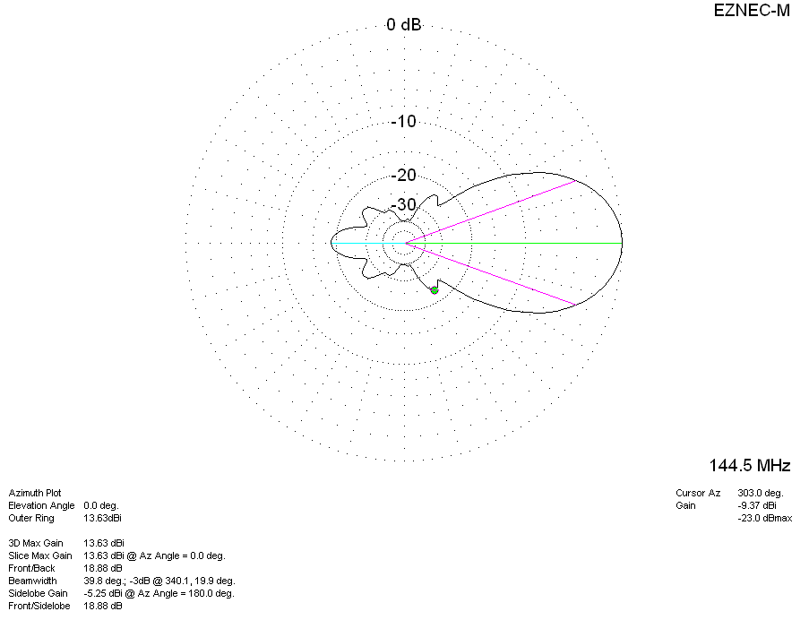
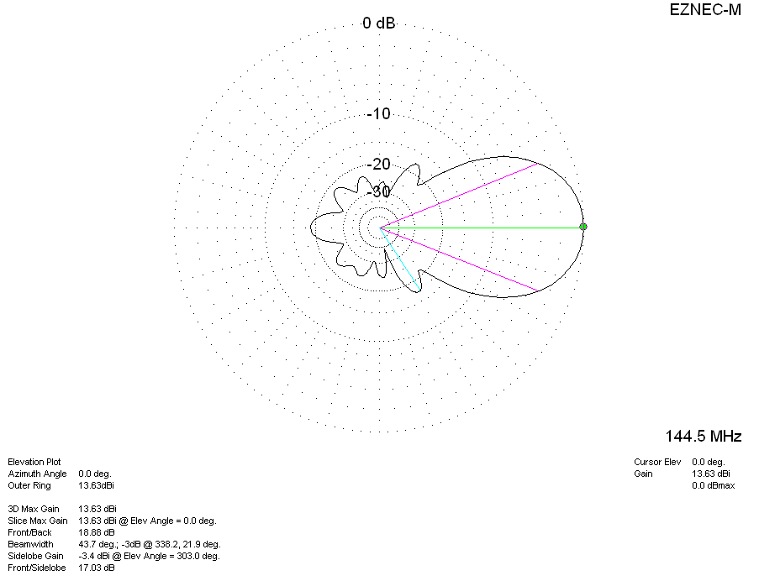
DIAGRAMS (losses included)
