ANTENNA Q207C2XL
PERFORMANCES: (No loss condition)
TYPE | ELE | L (mm) | G (dBi) | F/B (dB) | F/Sh (dBi) | F/Sv (dBi) | Hor (◦) | Ver (◦) | Temp (◦K) | G/T (dB) | ΔF * (kHz)
Q207C2XL | 7 | 3605 | 13,54 | 21,83 | 24,28 | 18,36 | 40,6 | 44,7 | 243,0 | -10,32 | 2850
* ΔF given for SWR=1,5

PERFORMANCES: (Losses included)
Element material | G (dBi) | Temp (◦K) | G/T (dB)
Aluminum rods | 13,46 | 244,0 | -10,41

DIMENSIONS:
 | Ref | De | D1 | D2 | D3 | D4 | D5 | REMARKS: : - All elements made of Al rods Ǿ5 mm  - The height of all rectangles is 300 mm  - All dimensions given in milimetres
Pos | 0 | 325 | 682 | 1295 | 2062 | 2809 | 3605
Length | 808 | 757 | 726 | 690 | 664 | 636 | 618

COMPARISON
Antenna | Boomlength (mm) | Material | Gain (dBi) | TA (◦K) | G/T (dB) | Bandwidth  (MHz)
Q207C2XL | 3605 | No loss | 13,54 | 243,0 | -10,32 | 142,700-145,550
Q207C2XL | 3605 | Aluminum | 13,46 | 244,0 | -10,41 | 142,700-145,550
EF0207-5 | 3274 | No loss | 12,95 | 255,9 | -11,13 | 140,500-145,100
EF0207-5 | 3274 | Aluminum | 12,86 | 256,8 | -11,25 | 140,500-145,100

DIAGRAMS (no loss included)
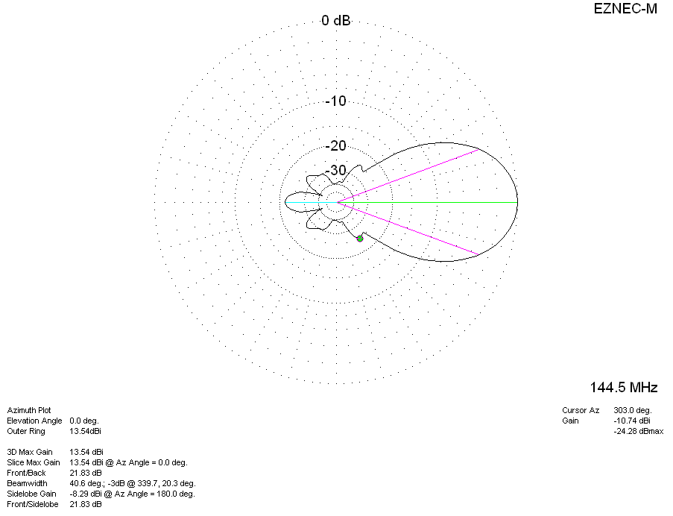
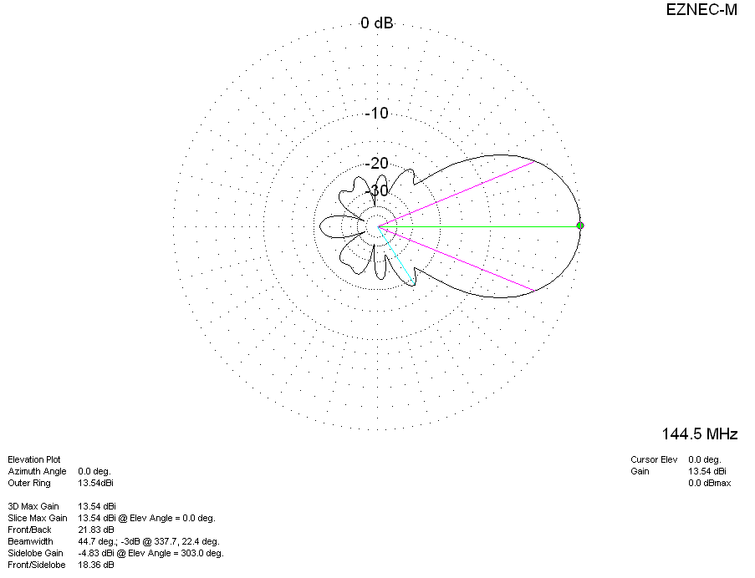
DIAGRAMS (losses included)
