ANTENNA Q207A1XL
PERFORMANCES: (No loss condition)
TYPE | ELE | L (mm) | G (dBi) | F/B (dB) | F/Sh (dBi) | F/Sv (dBi) | Hor (◦) | Ver (◦) | Temp (◦K) | G/T (dB) | ΔF * (kHz)
Q207A1XL | 7 | 3400 | 13,55 | 20,24 | 22,64 | 16,52 | 40,2 | 44,4 | 246,5 | -10,37 | 4150
* ΔF given for SWR=1,5

PERFORMANCES: (Losses included)
Element material | G (dBi) | Temp (◦K) | G/T (dB)
Aluminum rods | 13,48 | 247,3 | -10,45

DIMENSIONS:
 | Ref | De | D1 | D2 | D3 | D4 | D5 | REMARKS: : - All elements made of Al rods Ǿ5 mm  - The height of all rectangles is 140 mm  - All dimensions given in milimetres
Pos | 0 | 267 | 589 | 1137 | 1858 | 2635 | 3400
Length | 814 | 754 | 730 | 692 | 672 | 654 | 644

COMPARISON
Antenna | Boomlength (mm) | Material | Gain (dBi) | TA (◦K) | G/T (dB) | Bandwidth  (MHz)
Q207A1XL | 3400 | No loss | 13,55 | 246,5 | -10,37 | 143,500-147,600
Q207A1XL | 3400 | Aluminum | 13,48 | 247,3 | -10,45 | 143,500-147,600
EF0207-5 | 3274 | No loss | 12,95 | 255,9 | -11,13 | 140,500-145,100
EF0207-5 | 3274 | Aluminum | 12,86 | 256,8 | -11,25 | 140,500-145,100

DIAGRAMS (no loss included)
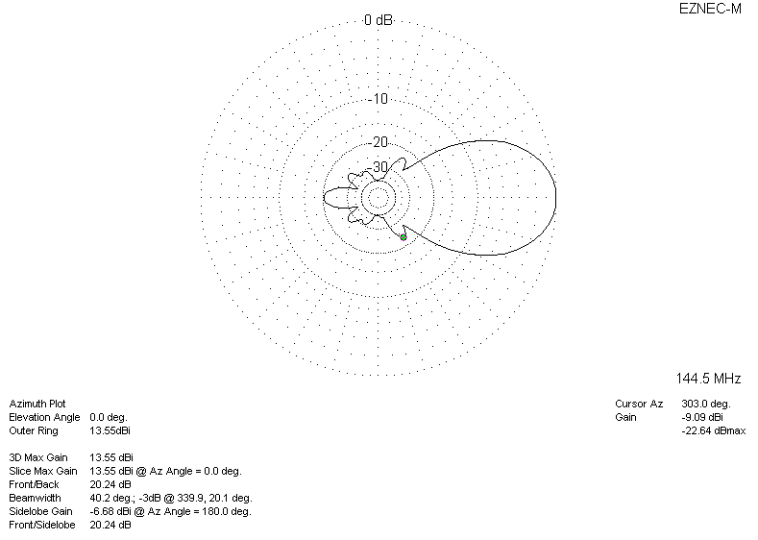
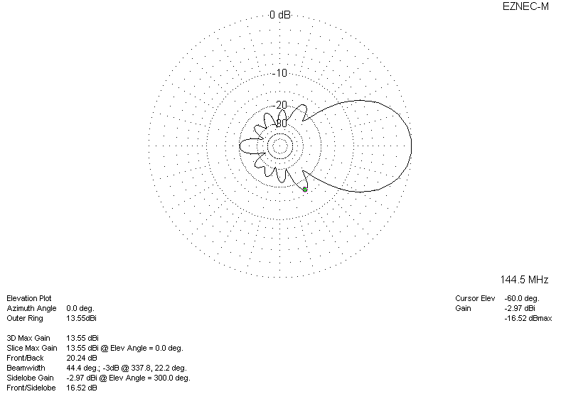
DIAGRAMS (losses included)
