ANTENNA Q206H2XL
PERFORMANCES: (No loss condition)
TYPE | ELE | L (mm) | G (dBi) | F/B (dB) | F/Sh (dBi) | F/Sv (dBi) | Hor (◦) | Ver (◦) | Temp (◦K) | G/T (dB) | ΔF * (kHz)
Q206H2XL | 6 | 2775 | 12,96 | 19,43 | 23,26 | 17,66 | 43,4 | 46,3 | 261,7 | -11,22 | 3560
* ΔF given for SWR=1,5

PERFORMANCES: (Losses included)
Element material | G (dBi) | Temp (◦K) | G/T (dB)
Aluminum rods | 12,86 | 262,5 | -11,33

DIMENSIONS:
 | Ref | De | D1 | D2 | D3 | D4 | REMARKS: : - All elements made of Al rods Ǿ5 mm  - The height of all rectangles is 510 mm  - All dimensions given in milimetres
Pos | 0 | 315 | 643 | 1226 | 1985 | 2775
Length | 618 | 574 | 554 | 534 | 508 | 488

COMPARISON
Antenna | Boomlength (mm) | Material | Gain (dBi) | TA (◦K) | G/T (dB) | Bandwidth  (MHz)
Q206H2XL | 2775 | No loss | 12,96 | 261,7 | -11,22 | 141,800-145,360
Q206H2XL | 2775 | Aluminum | 12,86 | 262,5 | -11,33 | 141,800-145,360
EF0206-5 | 2377 | No loss | 11,91 | 283,0 | -12,61 | 140,200-145,300
EF0206-5 | 2377 | Aluminum | 11,84 | 283,3 | -12,68 | 140,200-145,300
EF0207-5 | 3274 | No loss | 12,95 | 255,9 | -11,13 | 140,500-145,100
EF0207-5 | 3274 | Aluminum | 12,86 | 256,8 | -11,25 | 140,500-145,100

DIAGRAMS (no loss included)
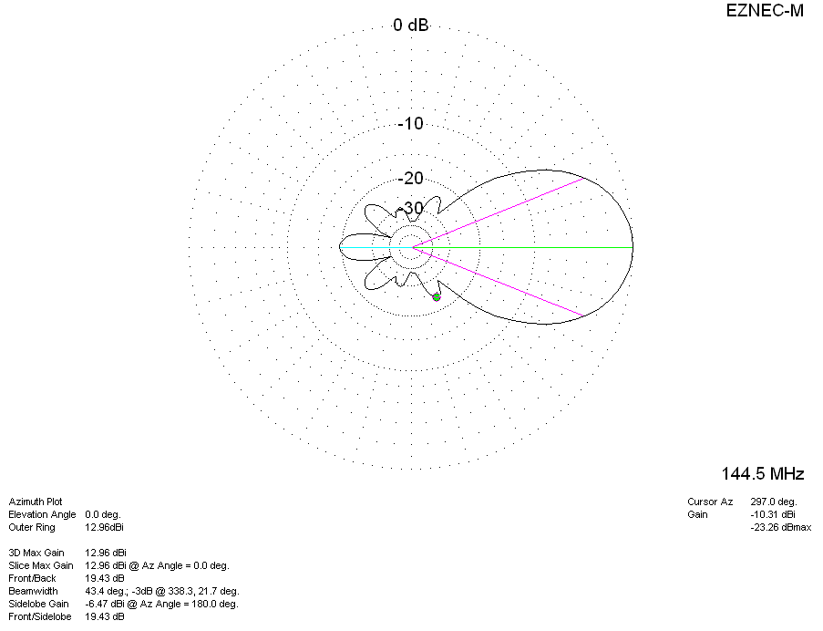
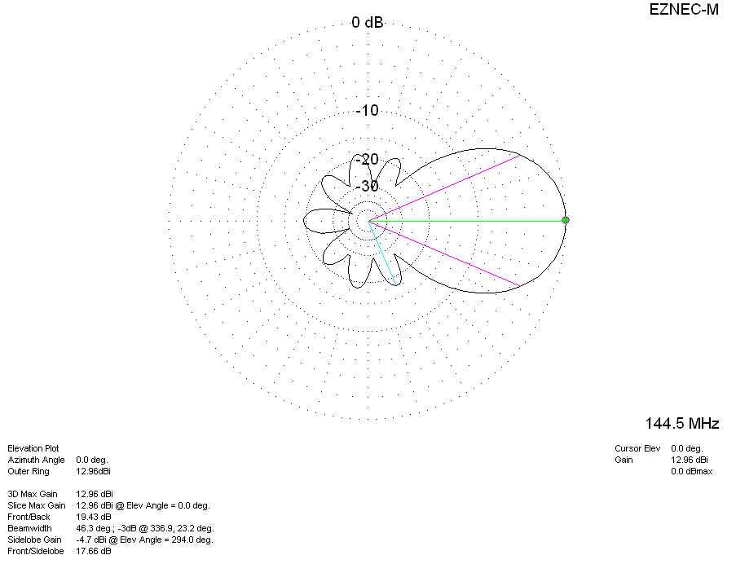
DIAGRAMS (losses included)
