ANTENNA Q206G7XL
PERFORMANCES:
TIP | ELE | L (mm) | G (dBi) | F/B (dB) | F/Sh (dBi) | F/Sv (dBi) | Hor (◦) | Ver (◦) | Temp (◦K) | G/T (dB) | ΔF * (MHz)
Q206G7XL | 6 | 2906 | 12,96 | 17,44 | 22,51 | 17,08 | 43,2 | 46,0 | 257,4 | -11,15 | 3,370
* ΔF given for SWR=1,5

PERFORMANCES: (Losses included)
Element material | G (dBi) | Temp (◦K) | G/T (dB)
Aluminum rods | 12,88 | 258,2 | -11,24

DIMENSIONS:
 | Ref | De | D1 | D2 | D3 | D4 | REMARKS: : - All elements made of Al rods Ǿ5 mm  - The width of all rectangles is 500 mm  - All dimensions given in milimetres
Pos | 0 | 417 | 812 | 1412 | 2187 | 2906
Length | 624 | 582 | 561 | 538 | 516 | 490

COMPARISON
Antenna | Boomlength (mm) | Material | Gain (dBi) | TA (◦K) | G/T (dB) | Bandwidth  (MHz)
Q206G7XL | 2906 | No loss | 12,96 | 257,4 | -11,15 | 142,000-145,270
Q206G7XL | 2906 | Aluminum | 12,88 | 258,2 | -11,24 | 142,000-145,270
EF0206-5 | 2377 | No loss | 11,91 | 283,0 | -12,61 | 140,200-145,300
EF0206-5 | 2377 | Aluminum | 11,84 | 283,3 | -12,68 | 140,200-145,300
EF0207-5 | 3274 | No loss | 12,95 | 255,9 | -11,13 | 140,500-145,100
EF0207-5 | 3274 | Aluminum | 12,86 | 256,8 | -11,25 | 140,500-145,100

DIAGRAMS (no loss included)

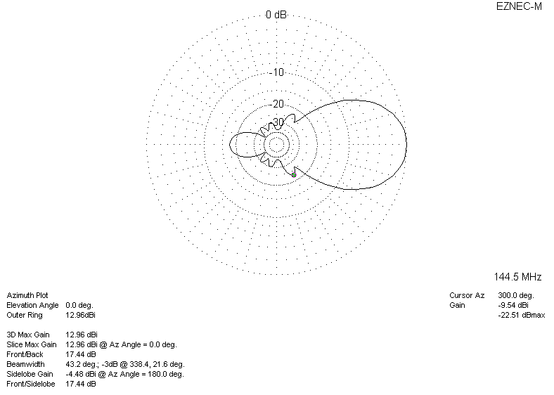
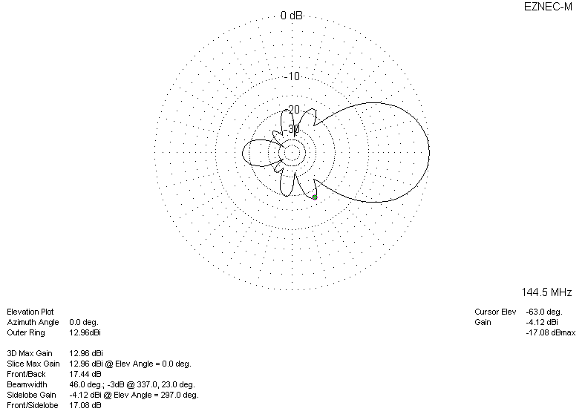
DIAGRAMS (loss included)
