ANTENNA Q206G1XL
PERFORMANCES: (No loss condition)
TYPE | ELE | L (mm) | G (dBi) | F/B (dB) | F/Sh (dBi) | F/Sv (dBi) | Hor (◦) | Ver (◦) | Temp (◦K) | G/T (dB) | ΔF * (kHz)
Q206G1XL | 6 | 2545 | 12,92 | 20,23 | 21,16 | 15,70 | 42,6 | 45,7 | 268,5 | -11,37 | 2190
* ΔF given for SWR=1,5

PERFORMANCES: (Losses included)
Element material | G (dBi) | Temp (◦K) | G/T (dB)
Aluminum rods | 12,81 | 269,3 | -11,49

DIMENSIONS:
 | Ref | De | D1 | D2 | D3 | D4 | REMARKS: : - All elements made of Al rods Ǿ5 mm  - The height of all rectangles is 470 mm  - All dimensions given in milimetres
Pos | 0 | 284 | 555 | 1099 | 1784 | 2545
Length | 646 | 602 | 588 | 576 | 552 | 532

COMPARISON
Antenna | Boomlength (mm) | Material | Gain (dBi) | TA (◦K) | G/T (dB) | BANDWIDTH  (MHz)
Q206G1XL | 2545 | No loss | 12,92 | 268,5 | -11,37 | 143,310-145,500
Q206G1XL | 2545 | Aluminum | 12,81 | 269,3 | -11,49 | 143,310-145,500
EF0206-5 | 2377 | No loss | 11,91 | 283,0 | -12,61 | 140,200-145,300
EF0206-5 | 2377 | Aluminum | 11,84 | 283,3 | -12,68 | 140,200-145,300
EF0207-5 | 3274 | No loss | 12,95 | 255,9 | -11,13 | 140,500-145,100
EF0207-5 | 3274 | Aluminum | 12,86 | 256,8 | -11,25 | 140,500-145,100

DIAGRAMS (no loss included)
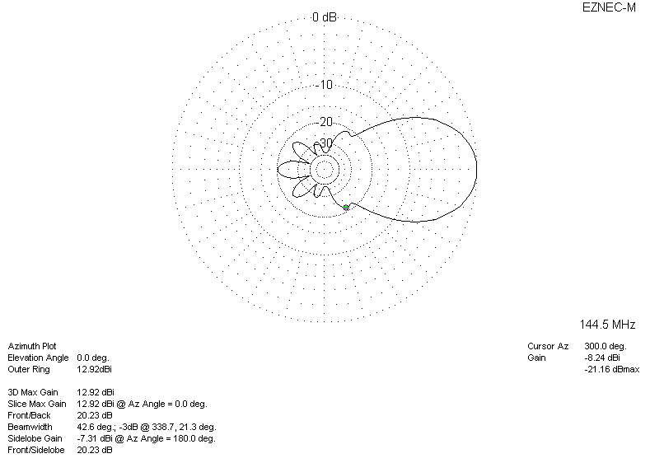
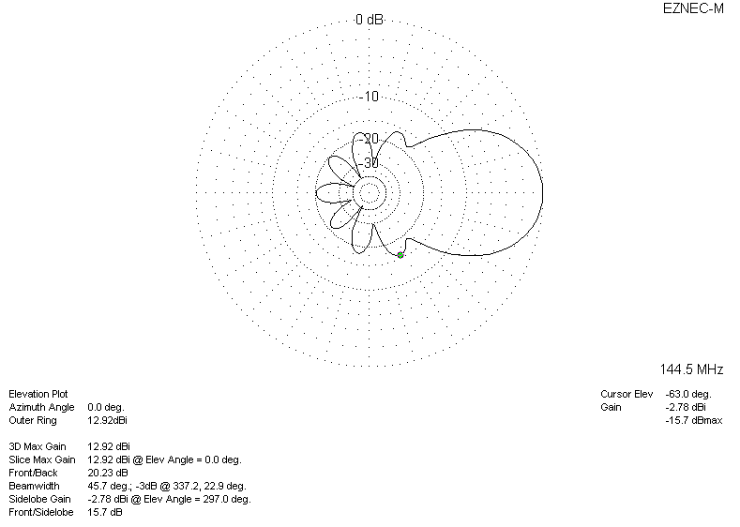
DIAGRAMS (losses included)
