ANTENNA Q205G1XL
PERFORMANCES: (No loss condition)
TYPE | ELE | L (mm) | G (dBi) | F/B (dB) | F/Sh (dBi) | F/Sv (dBi) | Hor (◦) | Ver (◦) | Temp (◦K) | G/T (dB) | ΔF * (kHz)
Q205G1XL | 5 | 1735 | 11,94 | 18,02 | 24,67 | 15,05 | 47,4 | 52,0 | 289,2 | -12,67 | 3050
* ΔF given for SWR=1,5

PERFORMANCES: (Losses included)
Element material | G (dBi) | Temp (◦K) | G/T (dB)
Aluminum rods | 11,85 | 289,3 | -12,76

DIMENSIONS:
 | Ref | De | D1 | D2 | D3 |  | REMARKS: : - All elements made of Al rods Ǿ5 mm  - The height of all rectangles is 470 mm  - All dimensions given in milimetres
Pos | 0 | 280 | 526 | 1099 | 1735
Length | 650 | 606 | 586 | 564 | 556

COMPARISON
Antenna | Boomlength (mm) | Material | Gain (dBi) | TA (◦K) | G/T (dB)
Q206G1XL | 1735 | No loss | 11,94 | 289,2 | -12,67
Q206G1XL | 1735 | Aluminum | 11,85 | 289,3 | -12,76
EF0206-5 | 2377 | No loss | 11,91 | 283,0 | -12,61
EF0206-5 | 2377 | Aluminum | 11,84 | 283,3 | -12,68

DIAGRAMS (no loss included)
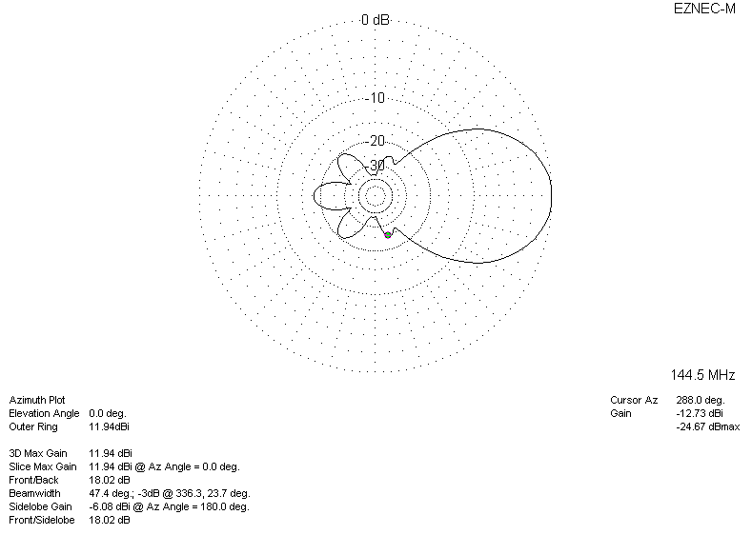
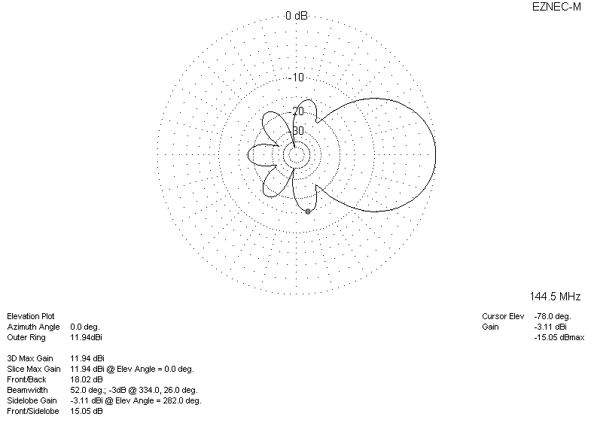
DIAGRAMS (losses included)
