ANTENNA Q205E1XL
PERFORMANCES: (No loss condition)
TYPE | ELE | L (mm) | G (dBi) | F/B (dB) | F/Sh (dBi) | F/Sv (dBi) | Hor (◦) | Ver (◦) | Temp (◦K) | G/T (dB) | ΔF * (kHz)
Q205E1XL | 5 | 1755 | 11,70 | 18,57 | 28,01 | 17,05 | 49,0 | 55,7 | 283,6 | -12,83 | 3800
* ΔF given for SWR=1,5

PERFORMANCES: (Losses included)
Element material | G (dBi) | Temp (◦K) | G/T (dB)
Aluminum rods | 11,62 | 283,6 | -12,91

DIMENSIONS:
 | Ref | De | D1 | D2 | D3 |  | REMARKS: : - All elements made of Al rods Ǿ5 mm  - The height of all rectangles is 400 mm  - All dimensions given in milimetres
Pos | 0 | 290 | 536 | 1118 | 1755
Length | 710 | 673 | 644 | 610 | 588

COMPARISON
Antenna | Boomlength (mm) | Material | Gain (dBi) | TA (◦K) | G/T (dB) | Bandwidth  (MHz)
Q205E1XL | 1755 | No loss | 11,70 | 283,6 | -12,83 | 142,300-146,100
Q205E1XL | 1755 | Aluminum | 11,62 | 283,6 | -12,91 | 142,300-146,100
EF0206-5 | 2377 | No loss | 11,91 | 283,0 | -12,61 | 140,300-145,300
EF0206-5 | 2377 | Aluminum | 11,84 | 283,3 | -12,68 | 140,300-145,300

DIAGRAMS (no loss included)
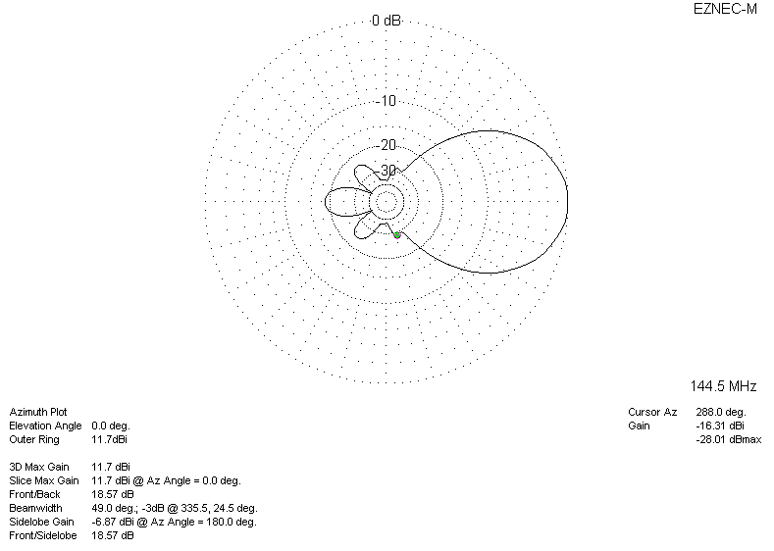
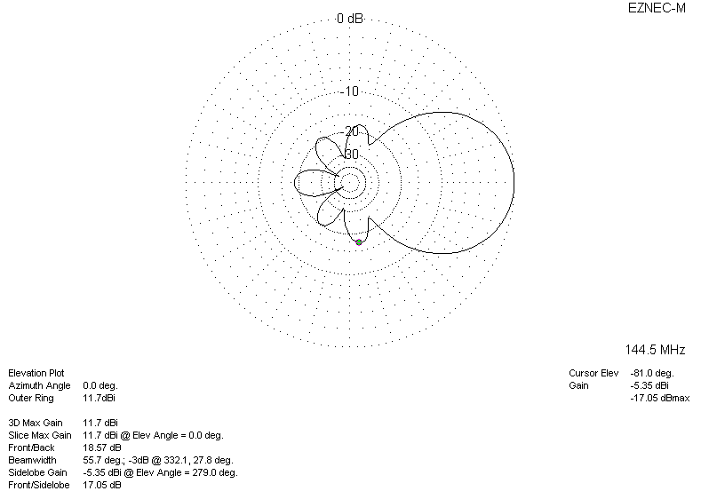
DIAGRAMS (losses included)
