PERFORMANCES: (No loss condition)
TYPE | ELE | L (mm) | G (dBi) | F/B (dB) | F/Sh (dBi) | F/Sv (dBi) | Hor (◦) | Ver (◦) | Temp (◦K) | G/T (dB) | ΔF * (kHz)
Q205D1XL | 5 | 2422 | 12,65 | 19,44 | 20,22 | 12,34 | 43,0 | 47,7 | 282,5 | -11,86 | 1380
* ΔF given for SWR=1,5

PERFORMANCES: (Losses included)
Element material | G (dBi) | Temp (◦K) | G/T (dB)
Aluminum rods | 12,58 | 283,0 | -11,94

DIMENSIONS:
 | Ref | De | D1 | D2 | D3 | REMARKS: : - All elements made of Al rods Ǿ5 mm  - The height of all rectangles is 350 mm  - All dimensions given in milimetres
Pos | 0 | 415 | 1.024 | 1705 | 2422
Length | 772 | 690 | 658 | 650 | 630

COMPARISON
Antenna | Boomlength (mm) | Material | Gain (dBi) | TA (◦K) | G/T (dB) | Bandwidth  (kHz)
Q205D1XL | 2422 | No loss | 12,54 | 277,9 | -11,90 | 143,720-145,100
Q205D1XL | 2422 | Aluminum | 12,58 | 283,0 | -11,94 | 143,720-145,100
EF0206-5 | 2377 | No loss | 11,91 | 283,0 | -12,61 | 140,300-145,300
EF0206-5 | 2377 | Aluminum | 11,84 | 283,3 | -12,68 | 140,300-145,300

DIAGRAMS (no loss included)
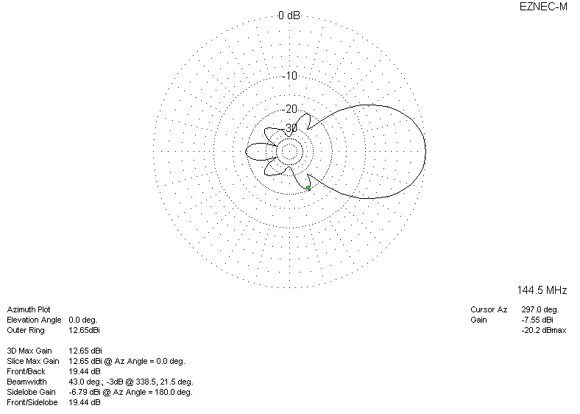
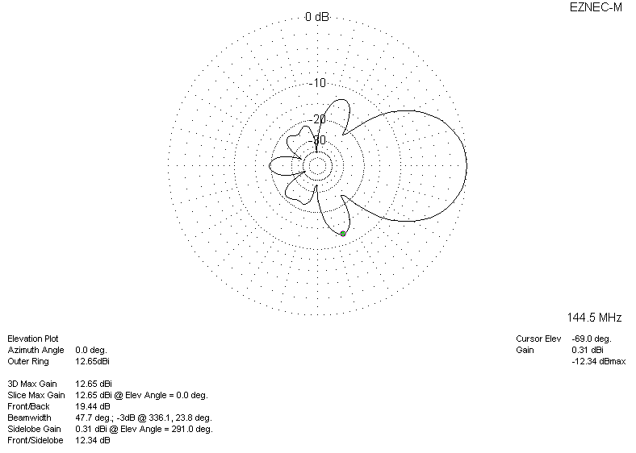
DIAGRAMS (losses included)
