ANTENNA Q204H6XL
PERFORMANCES: (No loss condition)
TYPE | ELE | L (mm) | G (dBi) | F/B (dB) | F/Sh (dBi) | F/Sv (dBi) | Hor (◦) | Ver (◦) | Temp (◦K) | G/T (dB) | ΔF * (kHz)
Q204H6XL | 4 | 1700 | 11,33 | 22,71 | 27,15 | 16,36 | 53,4 | 56,7 | 286,6 | -13,24 | 2400
* ΔF given for SWR=1,5

PERFORMANCES: (Losses included)
Element material | G (dBi) | Temp (◦K) | G/T (dB)
Aluminum rods | 11,27 | 286,0 | -13,31

DIMENSIONS:
 | Ref | De | D1 | D2 | REMARKS: : - All elements made of Al rods Ǿ5 mm  - The height of all rectangles is 600 mm  - All dimensions given in milimetres
Pos | 0 | 510 | 1050 | 1700
Length | 532 | 482 | 458 | 432

COMPARISON
Antenna | Boomlength (mm) | Material | Gain (dBi) | TA (◦K) | G/T (dB) | BANDWIDTH  (MHz)
Q204H6XL | 1700 | No loss | 11,33 | 286,6 | -13,24 | 143,300-145,430
Q204H6XL | 1700 | Aluminum | 10,27 | 286,0 | -13,31 | 143,300-145,430

DIAGRAMS (no loss included)
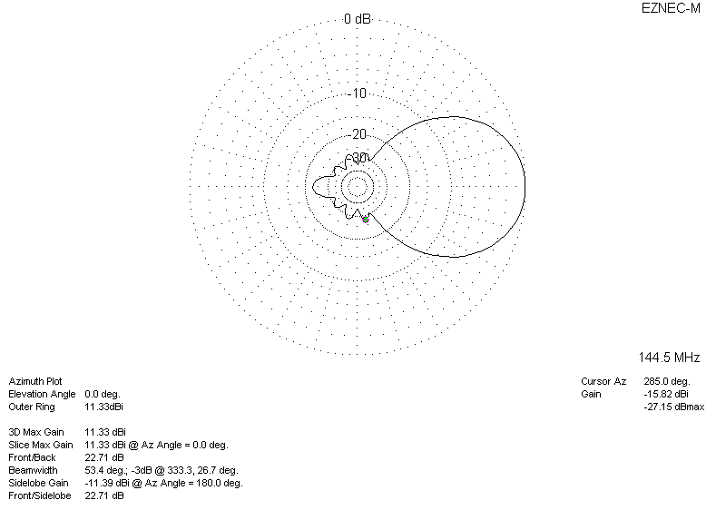
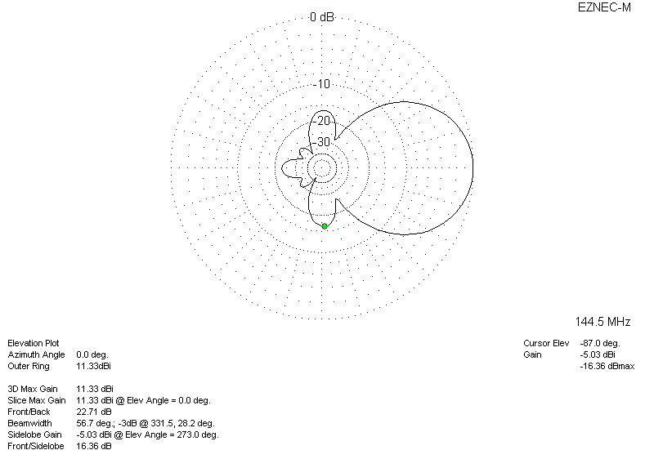
DIAGRAMS (losses included)
