ANTENNA Q204H4XL
PERFORMANCES: (No loss condition)
TYPE | ELE | L (mm) | G (dBi) | F/B (dB) | F/Sh (dBi) | F/Sv (dBi) | Hor (◦) | Ver (◦) | Temp (◦K) | G/T (dB) | ΔF * (kHz)
Q204H4XL | 4 | 1300 | 10,83 | 15,61 | 25,91 | 17,65 | 55,0 | 60,6 | 307,9 | -14,11 | 3500
* ΔF given for SWR=1,5

PERFORMANCES: (Losses included)
Element material | G (dBi) | Temp (◦K) | G/T (dB)
Aluminum rods | 10,77 | 307,4 | -14,17

DIMENSIONS:
 | Ref | De | D1 | D2 | REMARKS: : - All elements made of Al rods Ǿ5 mm  - The height of all rectangles is 550 mm  - All dimensions given in milimetres
Pos | 0 | 402 | 769 | 1300
Length | 570 | 538 | 506 | 478

COMPARISON
Antenna | Boomlength (mm) | Material | Gain (dBi) | TA (◦K) | G/T (dB) | BANDWIDTH  (MHz)
Q204H4XL | 1300 | No loss | 10,83 | 307,9 | -14,11 | 142,300-145,800
Q204H4XL | 1300 | Aluminum | 10,77 | 307,4 | -14,17 | 142,300-145,800

DIAGRAMS (no loss included)
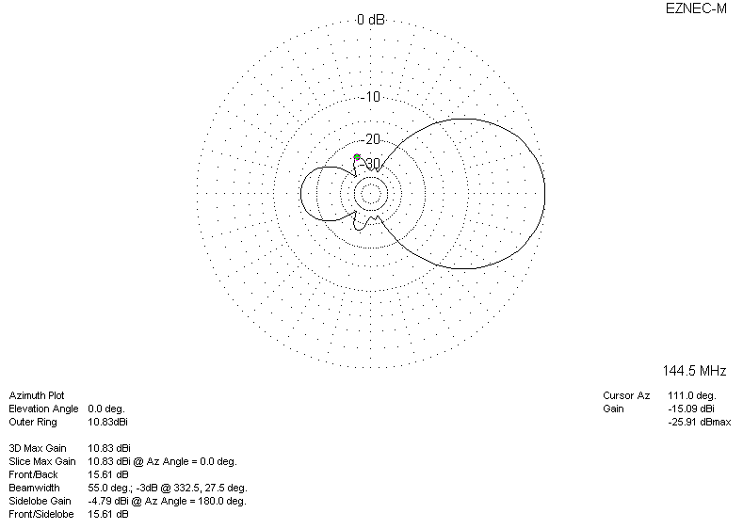
DIAGRAMS (losses included)
