ANTENNA Q204H1XL
PERFORMANCES: (No loss condition)
TYPE | ELE | L (mm) | G (dBi) | F/B (dB) | F/Sh (dBi) | F/Sv (dBi) | Hor (◦) | Ver (◦) | Temp (◦K) | G/T (dB) | ΔF * (kHz)
Q204H1XL | 4 | 1600 | 11,15 | 27,45 | 23,10 | 17,17 | 53,8 | 58,7 | 294,1 | -13,54 | 2400
* ΔF given for SWR=1,5

PERFORMANCES: (Losses included)
Element material | G (dBi) | Temp (◦K) | G/T (dB)
Aluminum rods | 11,10 | 293,9 | -13,58

DIMENSIONS:
 | Ref | De | D1 | D2 | REMARKS: : - All elements made of Al rods Ǿ5 mm  - The height of all rectangles is 550 mm  - All dimensions given in milimetres
Pos | 0 | 428 | 956 | 1600
Length | 572 | 530 | 494 | 470

COMPARISON
Antenna | Boomlength (mm) | Material | Gain (dBi) | TA (◦K) | G/T (dB) | BANDWIDTH  (MHz)
Q204H1XL | 1600 | No loss | 11,15 | 294,1 | -13,54 | 143,200-145,600
Q204H1XL | 1600 | Aluminum | 10,10 | 293,9 | -13,58 | 143,200-145,600

DIAGRAMS (no loss included)
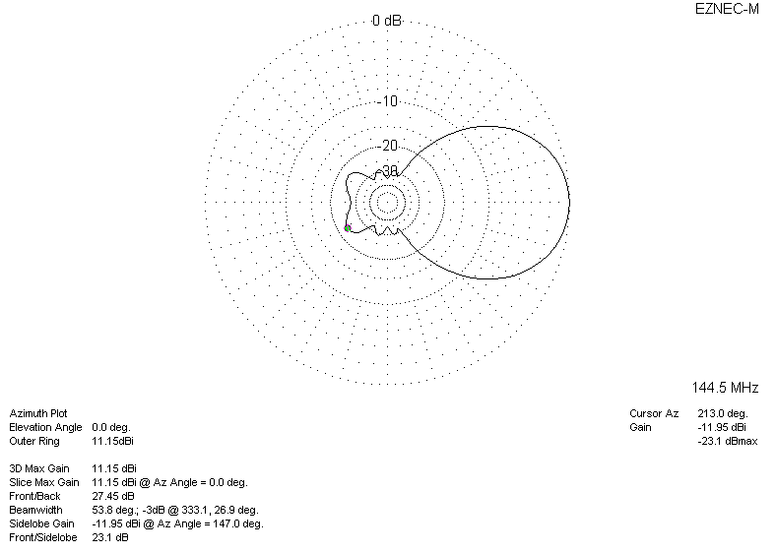
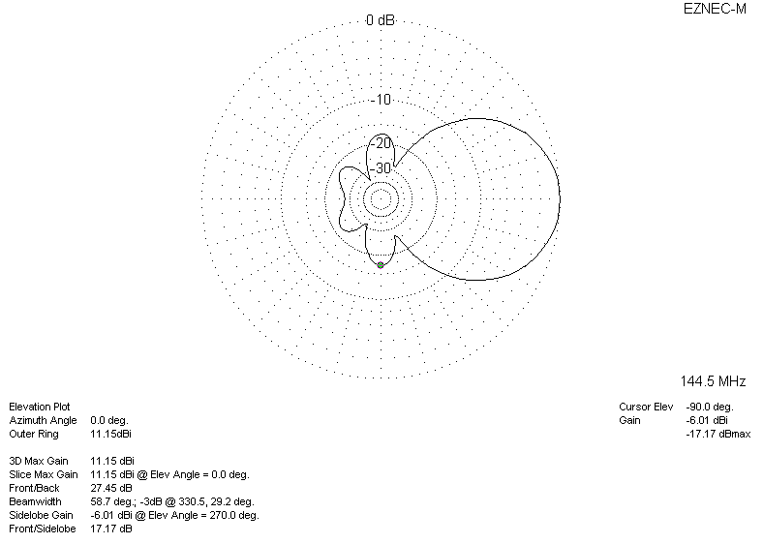
DIAGRAMS (losses included)
