PERFORMANCES: (No loss condition)
TYPE | ELE | L (mm) | G (dBi) | F/B (dB) | F/Sh (dBi) | F/Sv (dBi) | Hor (◦) | Ver (◦) | Temp (◦K) | G/T (dB) | ΔF * (kHz)
Q204G2XL | 4 | 1045 | 10,57 | 17,33 | 22,64 | 15,22 | 54,8 | 62,9 | 316,9 | -14,44 | 3940
* ΔF given for SWR=1,5

PERFORMANCES: (Losses included)
Element material | G (dBi) | Temp (◦K) | G/T (dB)
Aluminum rods | 10,50 | 316,3 | -14,50

DIMENSIONS:
 | Ref | De | D1 | D2 | REMARKS: : - All elements made of Al rods Ǿ5 mm  - The height of all rectangles is 470 mm  - All dimensions given in milimetres
Pos | 0 | 293 | 602 | 1045
Length | 650 | 606 | 584 | 556

COMPARISON
Antenna | Boomlength (mm) | Material | Gain (dBi) | TA (◦K) | G/T (dB) | Bandwidth  (MHz)
Q204G2XL | 1045 | No loss | 10,57 | 316,9 | -14,44 | 141,980-145,920
Q204G2XL | 1045 | Aluminum | 10,50 | 316,3 | -14,50 | 141,980-145,920

DIAGRAMS (no loss included)
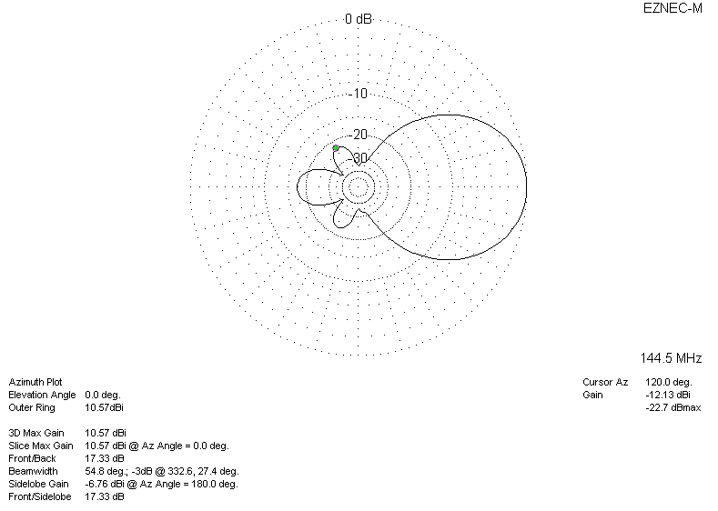
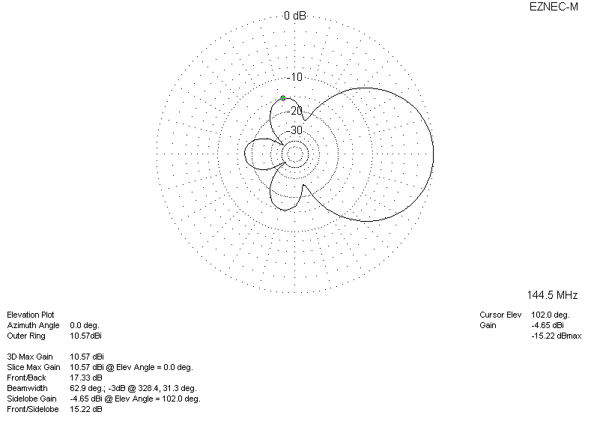
DIAGRAMS (losses included)
