ANTENNA Q204D1XL
PERFORMANCES: (No loss condition)
TYPE | ELE | L (mm) | G (dBi) | F/B (dB) | F/Sh (dBi) | F/Sv (dBi) | Hor (◦) | Ver (◦) | Temp (◦K) | G/T (dB) | ΔF * (kHz)
Q204D1XL | 4 | 1390 | 10,86 | 34,45 | 26,89 | 16,85 | 52,6 | 63,4 | 305,2 | -13,99 | 2210
* ΔF given for SWR=1,5

PERFORMANCES: (Losses included)
Element material | G (dBi) | Temp (◦K) | G/T (dB)
Aluminum rods | 10,81 | 304,9 | -14,03

DIMENSIONS:
 | Ref | De | D1 | D2 | REMARKS: : - All elements made of Al rods Ǿ5 mm  - The height of all rectangles is 320 mm  - All dimensions given in milimetres
Pos | 0 | 326 | 790 | 1390
Length | 794 | 730 | 690 | 644

COMPARISON
Antenna | Boomlength (mm) | Material | Gain (dBi) | TA (◦K) | G/T (dB) | BANDWIDTH  (MHz)
Q204D1XL | 1390 | No loss | 10,86 | 305,2 | -13,86 | 143,200-145,410
Q204D1XL | 1390 | Aluminum | 10,81 | 304,9 | -14,03 | 143,200-145,410

DIAGRAMS (no loss included)
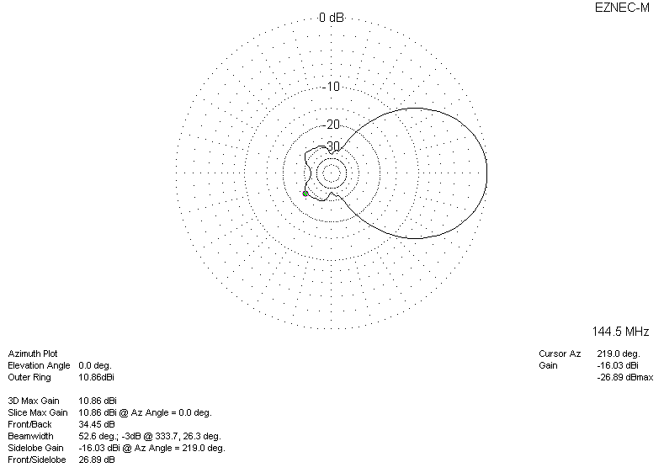
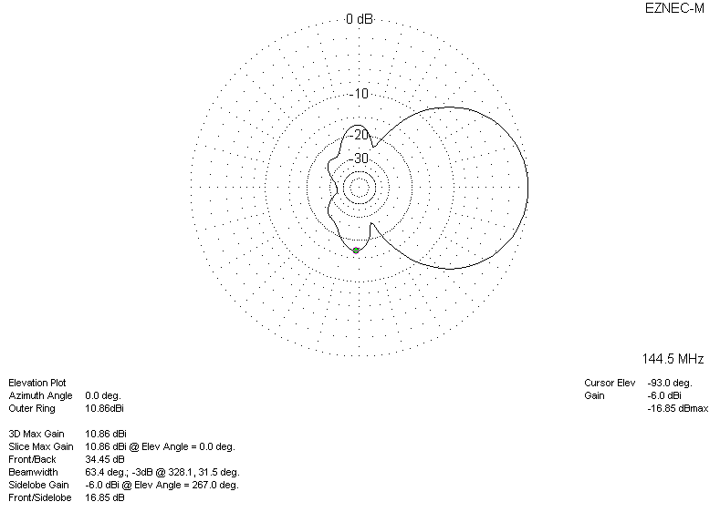
DIAGRAMS (losses included)
