ANTENNA Q203G1XL
PERFORMANCES: (No loss condition)
TYPE | ELE | L (mm) | G (dBi) | F/B (dB) | F/Sh (dBi) | F/Sv (dBi) | Hor (◦) | Ver (◦) | Temp (◦K) | G/T (dB) | ΔF * (kHz)
Q203G1XL | 3 | 223 | 8,10 | 13,75 | 24,27 | - | 68,4 | 93.3 | 417,0 | -18,10 | 3900
* ΔF given for SWR=1,5

PERFORMANCES: (Losses included)
Element material | G (dBi) | Temp (◦K) | G/T (dB)
Aluminum rods | 8,02 | 414,7 | -18,16

DIMENSIONS:
 | Ref | De | D1 | REMARKS: : - All elements made of Al rods Ǿ5 mm  - The height of all rectangles is 460 mm  - All dimensions given in milimetres
Pos | 0 | 160 | 223
Length | 656 | 618 | 572

COMPARISON
Antenna | Boomlength (mm) | Material | Gain (dBi) | TA (◦K) | G/T (dB) | BANDWIDTH  (MHz)
Q203G1XL | 223 | No loss | 8,10 | 417,0 | -18,10 | 142,100-146,00
Q203G1XL | 223 | Aluminum | 8,02 | 414,7 | -18,16 | 142,100-146,00

DIAGRAMS (no loss included)
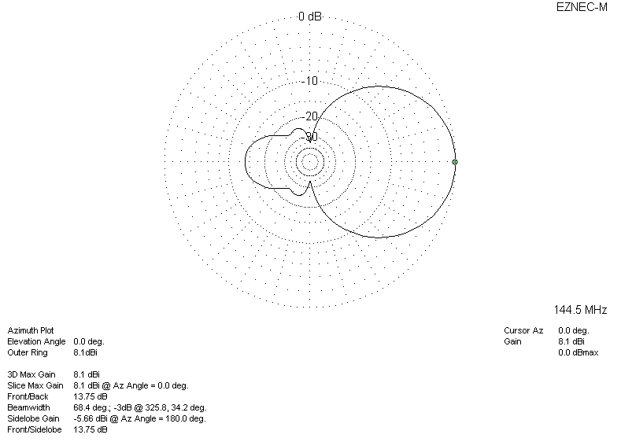
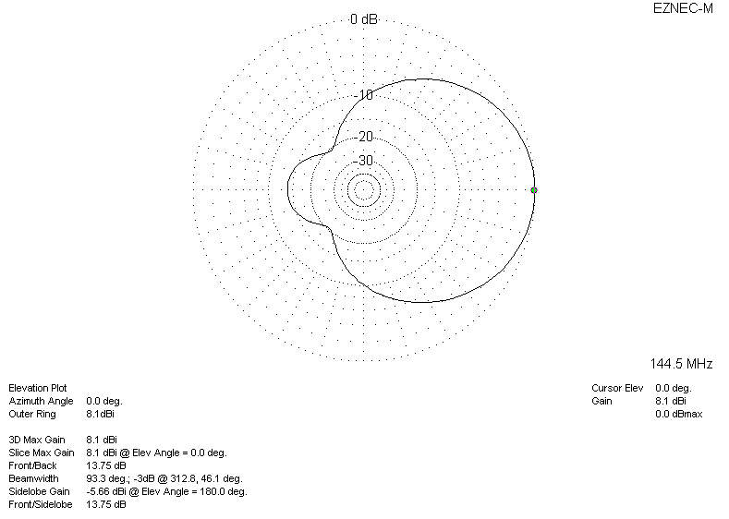
DIAGRAMS (losses included)
