ANTENNA Q203D2XL
PERFORMANCES: (No loss condition)
TYPE | ELE | L (mm) | G (dBi) | F/B (dB) | F/Sh (dBi) | F/Sv (dBi) | Hor (◦) | Ver (◦) | Temp (◦K) | G/T (dB) | ΔF * (kHz)
Q203D2XL | 3 | 567 | 8,57 | 22,43 | - | - | 63,4 | 88.3 | 381,6 | -17,25 | 2630
* ΔF given for SWR=1,5

PERFORMANCES: (Losses included)
Element material | G (dBi) | Temp (◦K) | G/T (dB)
Aluminum rods | 8,52 | 380,3 | -17,28

DIMENSIONS:
 | Ref | De | D1 | REMARKS: : - All elements made of Al rods Ǿ5 mm  - The height of all rectangles is 350 mm  - All dimensions given in milimetres
Pos | 0 | 352 | 567
Length | 698 | 672 | 664

COMPARISON
Antenna | Boomlength (mm) | Material | Gain (dBi) | TA (◦K) | G/T (dB) | BANDWIDTH  (MHz)
Q203D2XL | 567 | No loss | 8,57 | 381,6 | -17,25 | 143,020-145,650
Q203D2XL | 567 | Aluminum | 8,52 | 380,3 | -17,28 | 143,020-145,650

DIAGRAMS (no loss included)
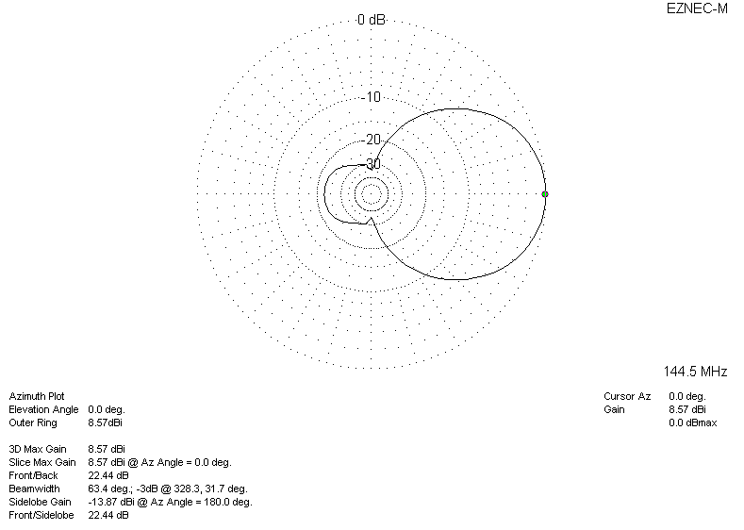
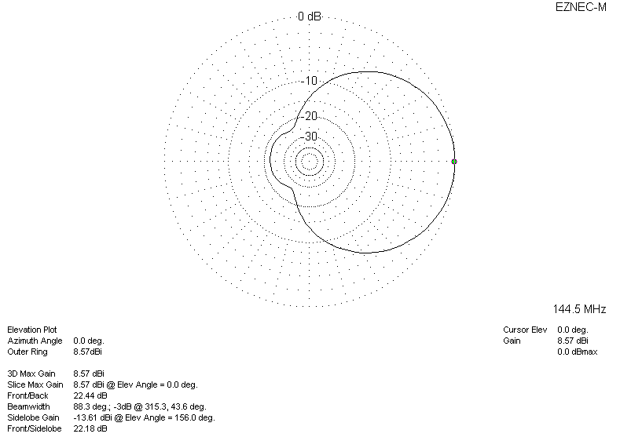
DIAGRAMS (losses included)
