ANTENNA QY21108XL4XPOL
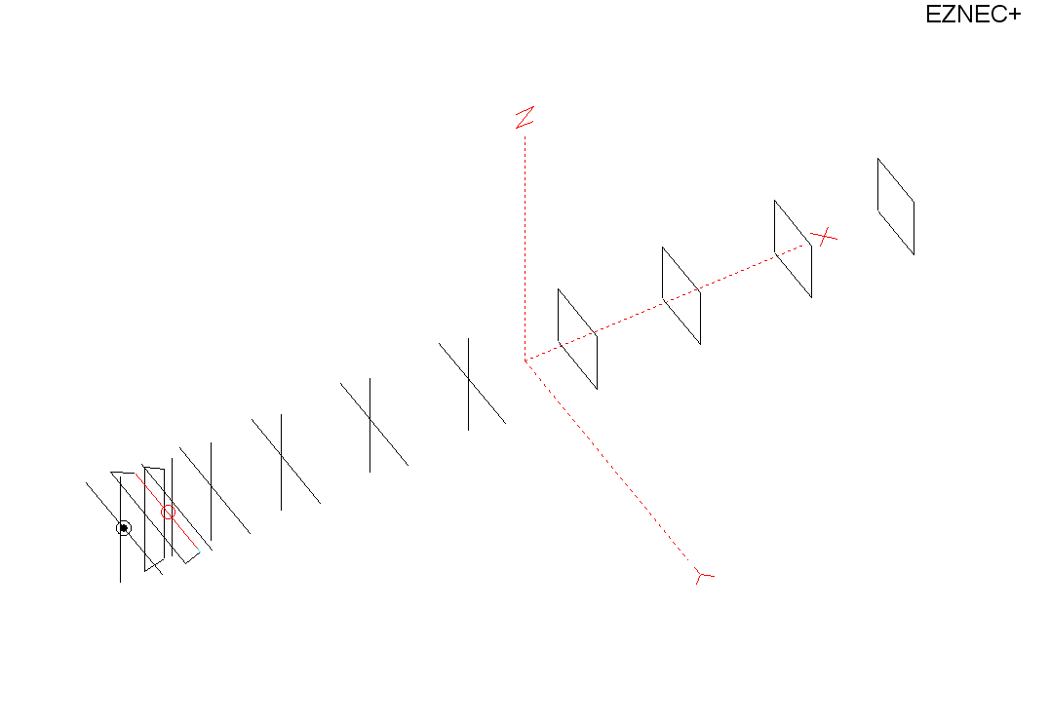
PERFORMANCES: (No loss condition)
TYPE | ELE | L (mm) | G (dBi) | F/B (dB) | F/Sh (dBi) | F/Sv (dBi) | Hor (◦) | Ver (◦) | Temp (◦K) | G/T (dB) | ΔF * (kHz)
Horizontal | 7Y+4Q | 6000 | 15,47 | 24,02 | 17,95 | 17,95 | 32,7 | 34,8 | 224,7 | -8,05 | 2900
Vertical | 7Y+4Q | 6000 | 15,48 | 24,61 | 18,32 | 19,25 | 34,7 | 32,8 | 225,6 | -8,05 | 2800
* ΔF given for SWR=1,5

PERFORMANCES: (Losses included)
Element material | G (dBi) | Temp (◦K) | G/T (dB)
Aluminum rods – horizontal | 15,39 | 226,1 | -8,15
Aluminum rods – vertical | 15,40 | 227,0 | -8,16

DIMENSIONS:
 | Ref | De1 | De2 | D1 | D2 | D3 | D4 | D5 | Q6 | Q7 | Q8 | Q9
Pos | 0 | 190 | 330 | 406 | 705 | 1255 | 1943 | 2705 | 3525 | 4335 | 5203 | 6000
Length | 1012 | 1000 | 900 | 942 | 948 | 924 | 904 | 886 | 526 | 502 | 496 | 476

MECHANICAL CONSIDERATION
- All elements made of Al rods Ǿ8 mm
- The height of the four + four rectangles is 500 mm
- All dimensions given in milimetres
- All yagi elements mounted through the boom, except DE2 which is shifted in Y-axis for 20mm, so that it can be attached to the surface of Al-boom 30x30mm
- Vertical and horizontal antenna elements are the same dimensions and positions
- Vertical elements positions are shifted back for 30mm, regarding horizontals

COMPARISON
Antenna | Boomlength (mm) | Material | Gain (dBi) | TA (◦K) | G/T (dB) | Bandwidth  (MHz)
QY20705XL1  horizontal | 6000 | No loss | 15,47 | 224,7 | -8,05 | 143,400-146,300
QY20705XL1  horizontal | 6000 | Aluminum | 15,39 | 226,1 | -8,15 | 143,400-146,300
QY20705XL1  vertical | 6000 | No loss | 15,47 | 224,7 | -8,05 | 143,400-146,200
QY20705XL1  vertical | 6000 | Aluminum | 15,40 | 227,0 | -8,16 | 143,400-146,200
EF0211B-5 | 5980 | No loss | 15,13 | 229,1 | -8,47 | 140,600-145,210
EF0211B-5 | 5980 | Aluminum | 15,03 | 256,8 | -8,60 | 140,600-145,210

HORIZONTAL PART
NO LOSS CONDITION
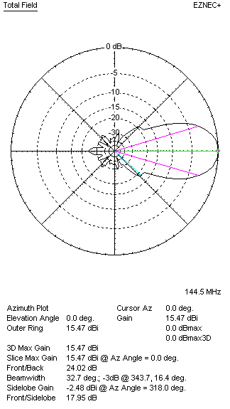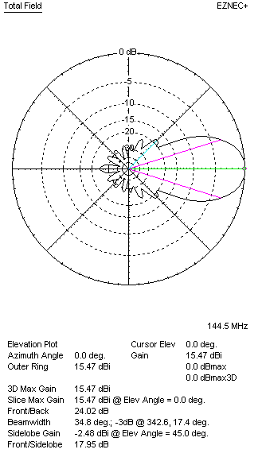

LOSS INCLUDED
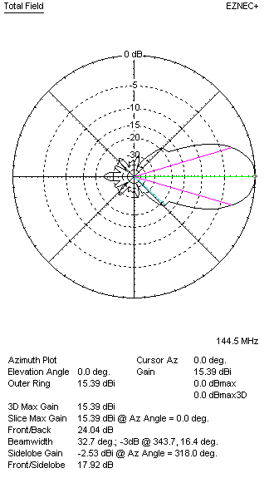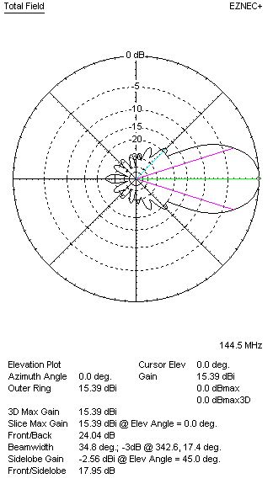
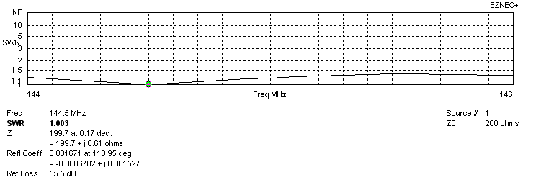
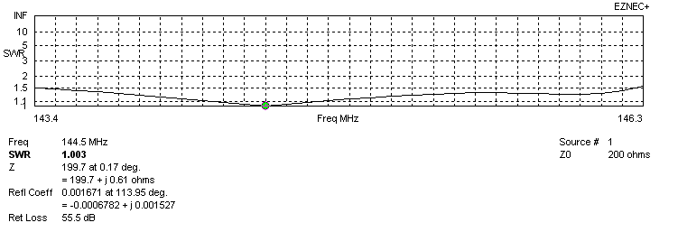
VERTICAL PART
NO LOSS CONDITION
LOSS INCLUDED – ALUMINUM
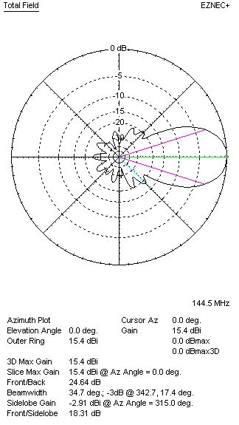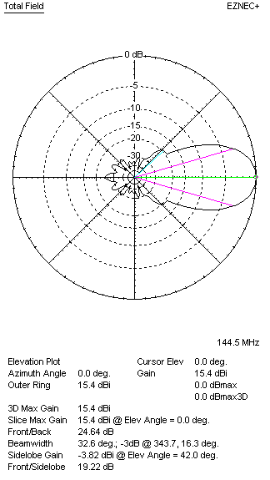
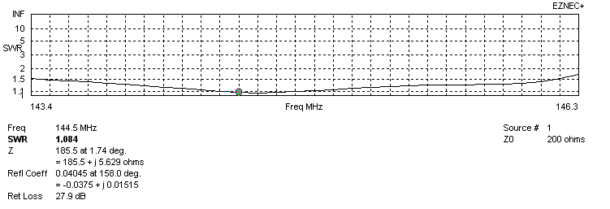
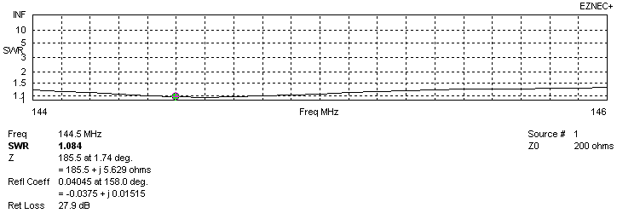

STACKING 350(H) x 340(V) cm

HORIZONTAL ANTENNA PATTERNS (Loss included) G=21,24 dBi TA=224,4 K G/T=-2,27 dB
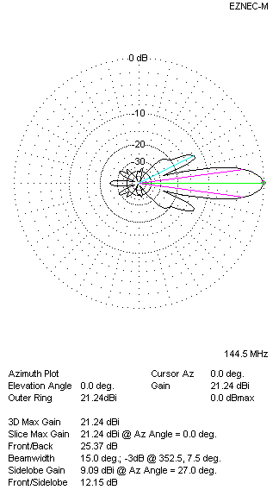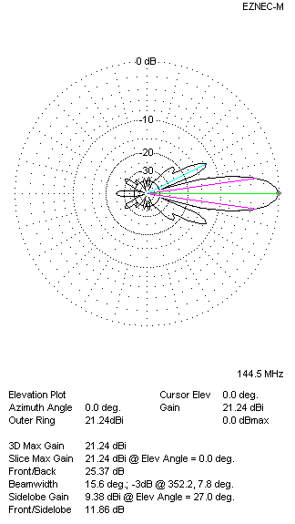

VERTICAL ANTENNA PATTERNS (Loss included) G=21,24 dBi TA=225,6 K G/T=-2,29 dB
