ANTENNA QY21105XL4
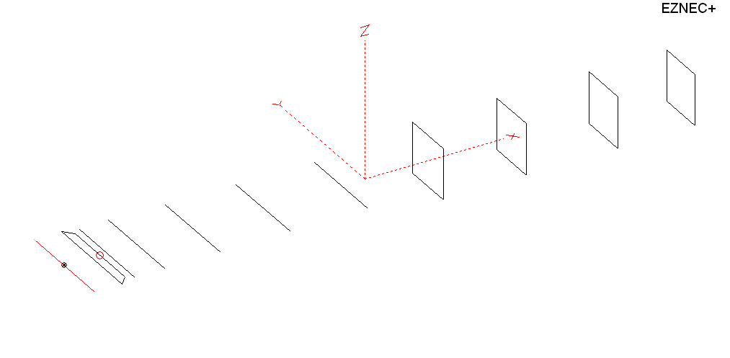
PERFORMANCES: (No loss condition)
TYPE | ELE | L (mm) | G (dBi) | F/B (dB) | F/Sh (dBi) | F/Sv (dBi) | Hor (◦) | Ver (◦) | Temp (◦K) | G/T (dB) | ΔF * (kHz)
QY21105XL4 | 11 | 6000 | 15,43 | 28,34 | 18,92 | 18,26 | 33,2 | 35,6 | 220,4 | -8,00 | 2900
* ΔF given for SWR=1,5

PERFORMANCES: (Losses included)
Element material | G (dBi) | Temp (◦K) | G/T (dB)
Aluminum rods | 15,33 | 222,5 | -8,14

DIMENSIONS:
 | Ref | De1 | De2 | D1 | D2 | D3 | D4 | D5 | DQ1 | DQ2 | DQ3 | DQ4 | REMARKS :  - All elements made of Al rods Ǿ5 mm  - The height of the rectangle is 500 mm  - All dimensions given in milimetres
Pos | 0 | 265 | 345 | 415 | 705 | 1250 | 1934 | 2695 | 3535 | 4355 | 5245 | 6000
Length | 1018 | 1018 | 850 | 946 | 958 | 932 | 916 | 900 | 522 | 500 | 492 | 476

COMPARISON
Antenna | Boomlength (mm) | Material | Gain (dBi) | TA (◦K) | G/T (dB) | Bandwidth  (MHz)
QY21105XL4 | 6000 | No loss | 15,43 | 220,4 | -8,00 | 143,200- 146,100
QY21105XL4 | 6000 | Aluminum | 15,33 | 222,5 | -8,14 | 143,200- 146,100
EF0211B-5 | 5980 | No loss | 15,13 | 229,1 | -8,47 | 140,600 -145,210
EF0211B-5 | 5980 | Aluminum | 15,03 | 256,8 | -8,60 | 140,600 -145,210
11ELKKA  G0KSC | 6048 | No loss | 15,22 | 228,7 | -8,37 | 142,500 – 145,470
11ELKKA  G0KSC | 6048 | Aluminum | 15,14 | 229,8 | -8,47 | 142,500 – 145,470
No boom correction included.

DIAGRAMS (no loss included)
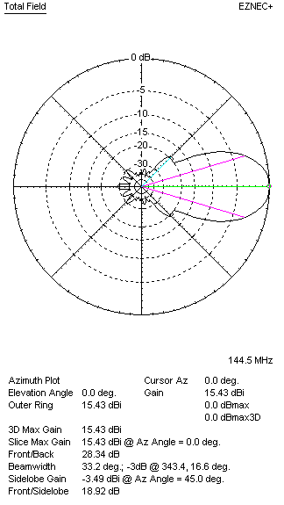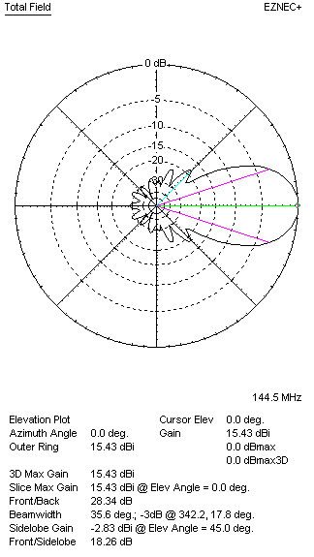
DIAGRAMS (losses included)
