ANTENNA QY20710XL7
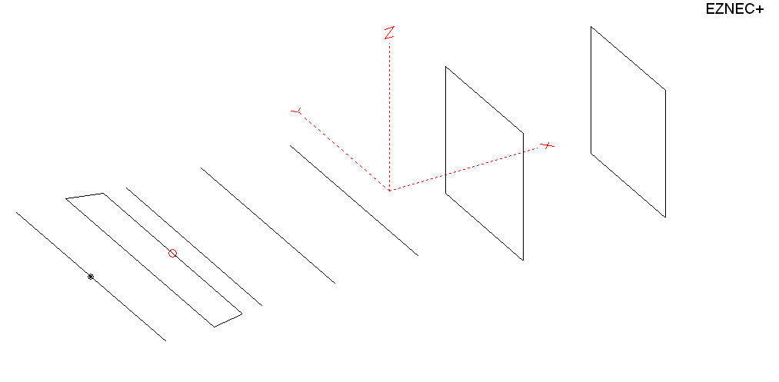
PERFORMANCES: (No loss condition)
TYPE | ELE | L (mm) | G (dBi) | F/B (dB) | F/Sh (dBi) | F/Sv (dBi) | Hor (◦) | Ver (◦) | Temp (◦K) | G/T (dB) | ΔF * (kHz)
QY20710XL7 | 7 | 2110 | 11,81 | 28,51 | 24,15 | 20,63 | 48,2 | 57,0 | 278,9 | -12,64 | 8050
* ΔF given for SWR=1,5

PERFORMANCES: (Losses included)
Element material | G (dBi) | Temp (◦K) | G/T (dB)
Aluminum rods | 11,78 | 278,9 | -12,68

DIMENSIONS:
 | Ref | De1 | De2 | D1 | D2 | D3 | DQ1 | DQ2 |  | REMARKS: : -All elements made of Al rods Ǿ10 mm  - The height of the rectangle is 500 mm  - All dimensions given in milimetres
Pos | 0 | 188 | 318 | 405 | 695 | 1035 | 1558 | 2110
Length | 1018 | 1010 | 926 | 932 | 924 | 886 | 524 | 504

COMPARISON
Antenna | Boomlength (mm) | Material | Gain (dBi) | TA (◦K) | G/T (dB) | Bandwidth  (MHz)
QY20710XL7 | 2110 | No loss | 11,81 | 278.9 | -12,64 | 138,400- 146,450
QY20710XL7 | 2110 | Aluminum | 11,78 | 278,9 | -12,68 | 138,400- 146,450
EF0206-5 | 2377 | No loss | 11,91 | 283,0 | -12,61 | 140,200 - 145,300
EF0206-5 | 2377 | Aluminum | 11,84 | 283,3 | -12,68 | 140,200 - 145,300
G0KSC 6ELE  EU | 2349 | No loss | 12,01 | 272,1 | -12,34 | 141,100 - 145,750
G0KSC 6ELE  EU | 2349 | Aluminum | 11,96 | 272,3 | -12,39 | 141,100 - 145,750
No boom correction included.

DIAGRAMS (no loss included)
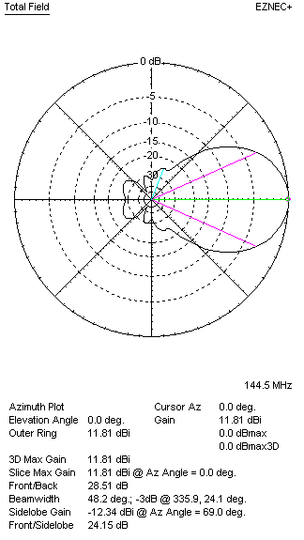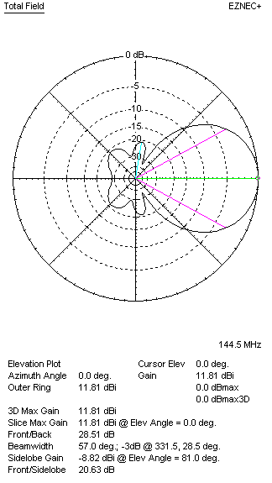
DIAGRAMS (losses included)
